Reading Starter 3 / New Edition
Book 3 Unit 1-5
A. Fill in the blanks with the correct word.
1. Terry wanted to buy a musical ____________, so he stopped by a music store.
a. tool | b. string |  |  | c. piano |  | d. instrument
2. Our first basketball game is ____________ for December.
a. scheduled | b. stopped |  |  | c. opened |  | d. canceled
3. Helen caught a fever. As a result, she became both ____________ and blind.
a. medicine |  | b. deaf |  | c. instrument |  | d. shook
4. Funland is a big ____________ with lots and lots of rides and games.
a. classroom | b. hospital |  | c. amusement park |  | d. department store
5. I saw the penguin in the street, and then it started ____________ me.
a. asking | b. running |  |  | c. replying |  | d. following

B. Match the related words.

1. wonderful |  | a. very good
2. top |  | b. best
3. communicate |  | c. walks after
4. spin |  | d. turn
5. follow |  | e. talk
C. Read and choose the right answers.
Simon wanted to buy a musical instrument, so he stopped by a music store. He was excited when he went into the store. He saw drums, guitars, flutes, and many other kinds of instruments there. However, his feelings soon changed. All the instruments were too expensive.
Then he had an idea. “I know,” he said, “I’ll make my own instrument!”
Simon found two paper plates and some glue. He also had string and some bells. First, he glued the paper plates together.
Then, he made holes around the plates. He tied the bells to the holes with the string. Finally, he drew faces on the plates.
He picked up his instrument and shook it. It made a wonderful sound!

- Simon ______________ by a music store to buy a musical instrument.
a. visited  c. invited | b. stopped  d. come

- All the instruments were too expensive to _____________.
a. donate  c. buy | b. sell  d. give

- He made his own instrument. True / False

Reading Starter 3 / New Edition
Book 3 Unit 6-10
A. Fill in the blanks with the correct word.
1. _____________ have long tails and look a little like small fish.
a. Tail | b. Face | c. Horse | d. Tadpole
2. Her friend Suzie _____________, “Try waking up at 6:30 instead.”
a. think | b. look for | c. find | d. suggested
3. The ____________ must be done by a doctor.
a. fee | b. cold | c. check-up | d. uniform
4. Now, just _____________ the “play” button to start playing.
a. press | b. fight | c. hero | d. punch
5. I left two ten-dollar ____________ on the table. That should be more than enough to buy all the groceries.
a. pounds | b. bills | c. foods | d. groceries

B. Match the related words.
1. small lake  2. almost  3. punch  4. sauce  5. strength | a. power  b. pond  c. nearly  d. hit  e. liquid

C. Read and choose True or False.
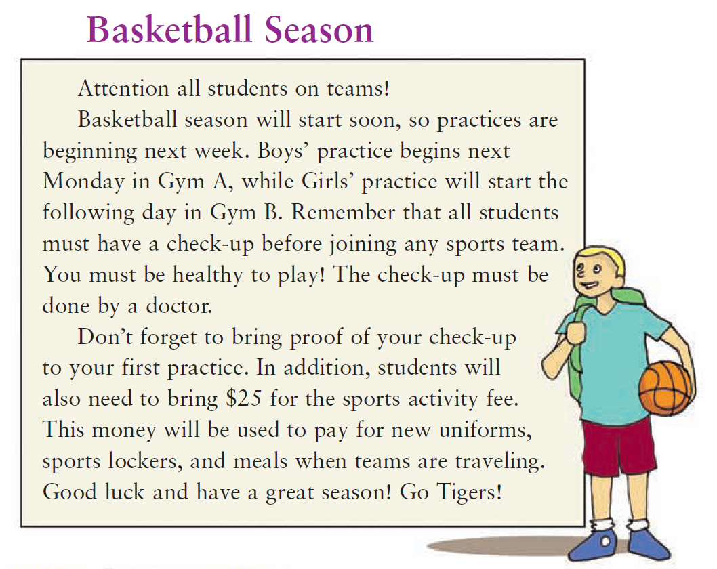

1. This is a letter. | True / False
2. All students must have a check-up before joining any sports team. | True / False
3. Students will need to bring $25 for the sports activity fee. | True / False
4. Girl’s practice will start in Gym A. | True / False
5. The check-up must be done by a doctor. | True / False

Reading Starter 3 / New Edition
Book 3 Unit 11-15
A. Fill in the blanks with the correct word.
1. Never get on a horse from the right side! The horse will become ____________.
a. annoyed | b. happy | c. stubborn | d. cold
2. Her mother made a cake with pink ____________.
a. frosting | b. birthday | c. house | d. dress
3. He has a fever, and he is also ____________ and sneezing.
a. frustrating. | b. coughing | c. laughing | d. annoying
4. Many people are surprised to ____________ that Stephen Hillenburg was once a science teacher.
a. drive | b. draw | c. find out | d. look like
5. SpongeBob SquarePants was ____________ in 1999.
a. drawn | b. deleted | c. introduced | d. taken

B. Match the related words.

1. softly |  | a. gently
2. teddy bear |  | b. different
3. sick |  | c. animal
4. separate |  | d. not healthy
5. creature |  | e. toy

C. Put them in the right order.
How to Make Tacos
1. |  | 2. |  | 3.
4. |  | 5. |  | 6.

_________-_________-_________-_________-_________-__________

Reading Starter 3 / New Edition
Book 3 Unit 16-20
A. Fill in the blanks with the correct word.
measure | better | tough | decide | alien
1. Terry’s letter really helped the family get through their ____________ time.
2. Every Saturday, my father and I wake up early and ____________ what to watch.
3. This year, the Lincoln team is much _____________.
4. Every week, Sam ____________(e)s the height of the tree and writes it down on a piece of paper.
5. Books and movies also tell stories about ______________(e)s on Mars.

B. Match the related words.

1. fourth |  | a. all
2. although |  | b. at this time
3. everything |  | c. last
4. final |  | d. number 4
5. yet |  | e. but
C. Read and choose the right answer.
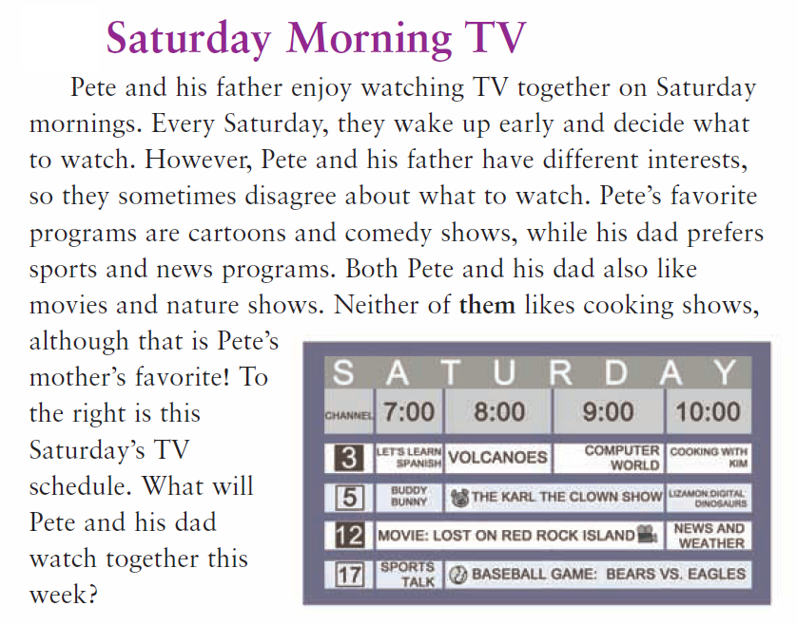

- What will Pete and his dad watch together this week? Choose two answers.
a. VOLCANOES  b. SPORTS TALK | b. COMPUTER WORK  d. MOVIE : LOST ON RED ROCK ISLAND
- Every Saturday, Pete and his father wake up early and decide ____________ watch.
a. how to | b. what to

Reading Starter 3 / New Edition

Book 3 Unit 1-5
A.
1. d
2. a
3. b
4. c
5. d

B.
1- a
2- b
3- e
4- d
5- c

C.
1. b
2. c
3. True

Book 3 Unit 6-10
A.
1. d
2. d
3. c
4. a
5. b

B.
1. b
2. c
3. d
4. e
5. a

C.
1- F
2- T
3- T
4- F
5- T

Book3 Unit 11-15
A.
1. a
2. a
3. b
4. c
5. c

B.
1- a
2- e
3- d
4- b
5- c

C.
4-2-3-5-1-6

Book 3 Unit 16-20
A.
1. tough
2. decide
3. better
4. measure
5. alien

B.
1- d
2- e
3- a
4- c
5- b

C.
1. a,d
2. d

