School Subject Readings Final Test
Units 11-20
A. Fill in the blank with the correct word.
makeup | monster | taste | cane | planet
dropped | waiting | powdered | light | seagulls
1. My grandfather uses his _____________ to help him walk.
2. Many women think that _____________ makes them look nicer.
3. We use _____________ soap in our washing machine.
4. Turn on the _____________; I can’t see anything.
5. Which _____________ is closest to earth?
6. The little boy was scared because he thought there was a _____________ in his closet.
7. Does this soup _____________ too salty to you?
8. I _____________ my phone and it broke.
9. There are many _____________ near the beach.
10. I hate _____________ in lines at the amusement park.
B. Match the related words.
1. sick | a. tasty
2. planet | b. broken arm
3. closet | c. medicine
4. candy | d. clothes
5. cast | e. Saturn

C. Read and write the correct numbers in the boxes.
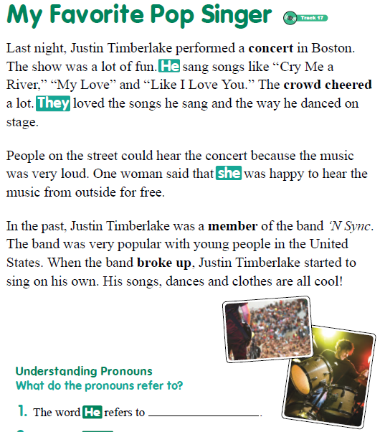
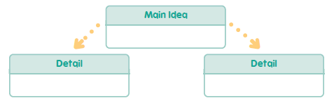
1. Justin Timberlake was a member of ‘N Sync.
2. There was a Justin Timberlake concert last night.
3. The music was loud enough to hear outside.
School Subject Readings Final Test
Units 11-20

A.
1. cane
2. makeup
3. powdered
4. light
5. planet
6. monster
7. taste
8. dropped
9. seagulls
10. waiting

B.
1. c
2. e
3. d
4. a
5. b

C.
Main Idea: 2
Detail: 1,3

