School Subject Readings 1 Midterm Test
Units 1-10
A. Fill in the blanks with the correct words.
shopping | highway | cubs | bully | leaves
pillow | inside | race | travel | lunch

1. The _____________ cars can go really fast!
2. I need to go _____________ for a new school clothes.
3. The _____________ always yells at his classmates—he’s really mean.
4. I would like to _____________ to France one day.
5. The _____________ on most trees change color in fall.
6. The mama bear watches closely over her _____________.
7. You can drive faster on a _____________ than on a smaller road.
8. I fall asleep quickly now that I bought a softer _____________.
9. We usually eat _____________ at noon.
10. I like to play _____________ during the winter because it is too cold outside.
B. Match the related words.
1. pillow | a. rabbit
2. fur | b. sandwich
3. sneakers | c. car
4. lunch | d. bed
5. wheel | e. basketball

C. Read and put the events in order.
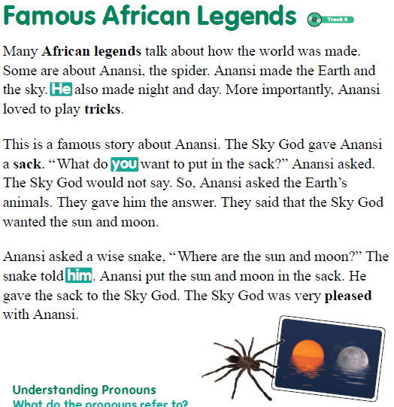
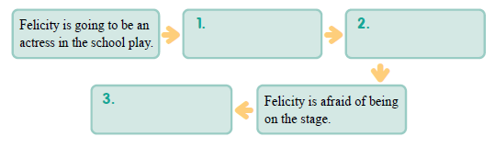
a. Anansi didn’t know what to put in the sack.
b. Anansi gave the Sky God the sun and moon.
c. The Sky God gave Anansi a sack.
d. Anansi asked the animals what to put in the sack.
e. The Sky God was pleased.
School Subject Readings 1 Midterm Test
Units 1-10

A.
1. race
2. shopping
3. bully
4. travel
5. leaves
6. cubs
7. highway
8. pillow
9. lunch
10. inside

B.
1. d
2. a
3. e
4. b
5. c

C.
1. c
2. a
3. d
4. b
5. e

