School Subject Readings Final Test
Units 11-20
A. Fill in the blanks with the correct word.
winner | exciting | president | knocked over | caves
palm tree | believe | ocean | careful | nickname

1. Coconuts come from one type of _______________.
2. Deana goes by her _______________, “Deedee.”
3. The _______________ of the game will be the world champion.
4. Some bears like to sleep in _______________.
5. Young children often _______________ that there are monsters.
6. I _______________ the flower pot when I fell.
7. It is really _______________ to ride the rollercoaster.
8. I was very _______________ not to spill the hot coffee.
9. George Washington was the first _______________ of the US.
10. I like to surf when I go to the _______________.

B. Match the related words.
1. key | a. gun
2. army | b. vacation
3. tour | c. palm tree
4. button | d. lock
5. ocean | e. pants

D. Read the passage and circle True or False.
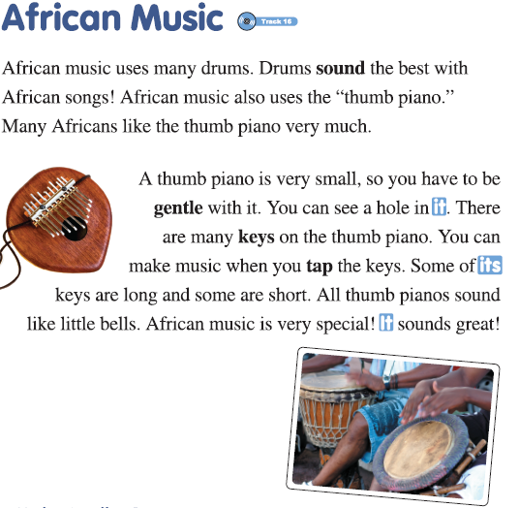

1. There are many strings on a thumb piano. | True / False
2. African music has lots of drum sounds. | True / False
3. The thumb piano only has long keys. | True / False
4. You must give it a hard tap to make a sound. | True / False
5. It sounds like little bells. | True / False
School Subject Readings Final Test
Units 11-20
A.
1. palm tree
2. nickname
3. winner
4. caves
5. believe
6. knocked over
7. exciting
8. careful
9. president
10. ocean

B.
1. d
2. a
3. b
4. e
5. c

C.
1. False
2. True
3. False
4. False
5. True

