School Subject Readings 2 Midterm Test
Units 1-10
A. Fill in the blanks with the correct word.
yard | puddles | pythons | contest | battles
presents | bothers | robots | spend | raft
1. Today _______________ do much of the work people used to do in the past.
2. There can be many _______________ during a war.
3. The cricket in my home _______________ me at night.
4. The fat man won the eating _______________—he ate thirty hotdogs.
5. We should build a _______________ to float across the river.
6. I have beautiful flowers in my _______________.
7. _______________ are big snakes that live in Asia, Africa, and Australia.
8. My parents give me _______________ on my birthday.
9. I always _______________ too much money at the bookstore.
10. I like to jump in _______________ after it rains.

B. Match the related words.
1. mud | a. king
2. lawn | b. ship
3. spend | c. dirt
4. crown | d. money
5. sailor | e. grass
C. Read and choose the main idea and the details that support it from the sentences below. Write the correct number in the boxes.
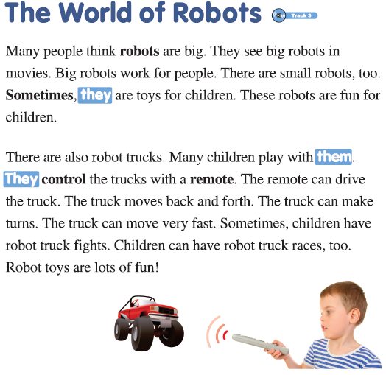
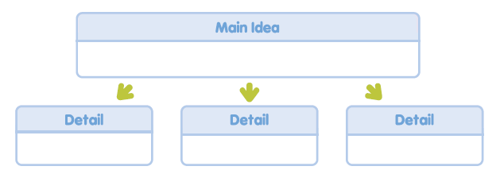
1. Children can have robot truck races.
2. Robot trucks can move back and forth.
3. Robot trucks can be fast.
4. Robot trucks can be toys for children.

School Subject Readings 2 Midterm Test
Units 1-10

A.
1. robots
2. battles
3. bothers
4. contest
5. raft
6. yard
7. Pythons
8. presents
9. spend
10. puddles

B.
1. c
2. e
3. d
4. a
5. b

C.
Main Idea: 4
Details: 1, 2, 3

