School Subject Readings 3 Final Test
Units 11-20
A. Fill in the blanks with the correct word.
warmhearted | swing | amazing | islands | hope
gas | earthquakes | flight | terrified | member
1. Hawaii is a group of ______________.
2. ______________ make the ground shake.
3. My ______________ from the US to India was long.
4. Monkeys like to ______________ in the trees.
5. I ______________ this lottery ticket is a winner.
6. I was ______________ when I saw the aggressive dog.
7. My mother is very caring and ______________.
8. I am a(n) ______________ of the Sierra Club.
9. The firework display was ______________.
10. My electric car does not use any ______________.

B. Match the related words.
1. island | a. children
2. flight | b. Big Ben
3. clock | c. trees
4. clever | d. plane
5. pack | e. boat
6. prey | f. suitcase
7. jungle | g. summer
8. sail | h. Jeju
9. heat | i. smart
10. orphanage | j. mice
D. Read and put the events in order.
Brenda’s First Plane Trip
Dear Mark,
Yesterday, I was on my first flight. It was a lot of fun! I looked out the window. The buildings got smaller and smaller. From up high, looked like little toys. I wanted to look for my town from the sky, but I couldn’t find it.
After we were up in the air, the flight attendant brought us some water and juice. Then we watched a movie. The movie was entertaining. I really liked!
Later, I looked at the clock. We were in the air for four hours. The plane was shaking a little bit and felt terrified. My mom told me it was OK. A few minutes later, the plane landed on the ground.
See you soon!
Brenda
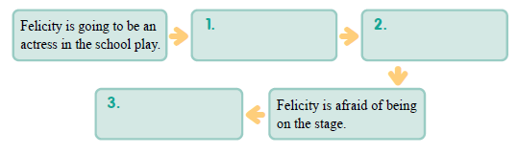
a. Brenda couldn’t find her town.
b. Brenda looked out the window.
c. The buildings looked like little toys.
d. They watched a movie.
e. Brenda was terrified.

School Subject Readings 3 Final Test
Units 11-20

A.
1. islands
2. Earthquakes
3. flight
4. swing
5. hope
6. terrified
7. warmhearted
8. member
9. amazing
10. gas

B.
1. h
2. d
3. b
4. i
5. f
6. j
7. c
8. e
9. g
10. a

C.
1. b
2. c
3. b
4. d
5. e

