 | 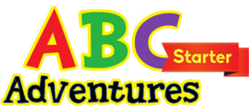 |  | Word List |  |  | 
Class |  |  |  | Name

Lesson 1

Picture | Word | Picture | Word
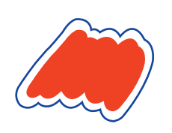 | red |  | one
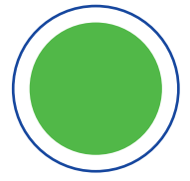 | circle | 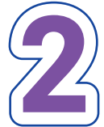 | two
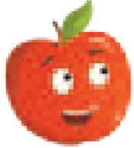 | apple | 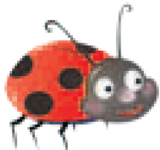 | ladybug

 |  |  | Word List
Class |  |  |  | Name

Lesson 2

Picture | Word | Picture | Word
 | yellow | 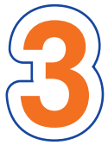 | three
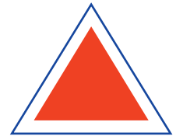 | tr | 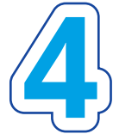 | four
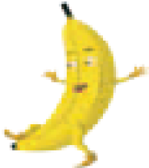 | banana | 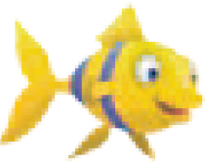 | fish

 |  |  | Word List
Class |  |  |  | Name

Lesson 3

Picture | Word | Picture | Word
 | blue | 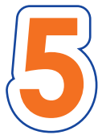 | five
 | square | 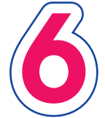 | six
 | bluebird | 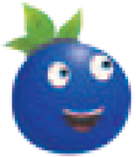 | blueberry

 |  |  | Word List
Class |  |  |  | Name

Lesson 4 – Review

Picture | Word | Picture | Word
 | red |  | one
 | circle |  | two
 | yellow |  | three
 | triangle |  | four
 | blue |  | five
 | square |  | six

 |  |  | Word List
Class |  |  |  | Name

Lesson 5

Picture | Word | Picture | Word
 | orange |  | seven
 | rectangle | 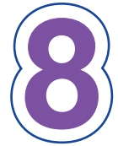 | eight
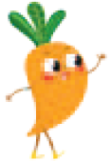 | carrot |  | basketball

 |  |  | Word List
Class |  |  |  | Name

Lesson 6

Picture | Word | Picture | Word
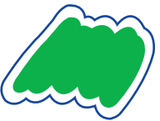 | green | 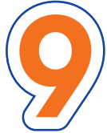 | nine
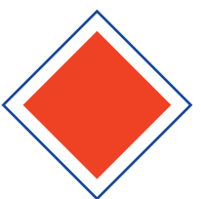 | diamond | 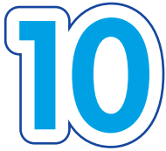 | ten
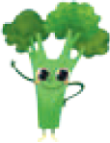 | broccoli | 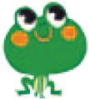 | frog

 |  |  | Word List
Class |  |  |  | Name

Lesson 7

Picture | Word | Picture | Word
 | purple |  | one
 | star | 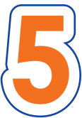 | five
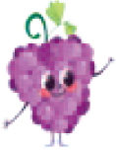 | grape | 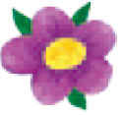 | flower

 |  |  | Word List
Class |  |  |  | Name

Lesson 8 - Review

Picture | Word | Picture | Word
 | orange |  | six
 | rectangle |  | seven
 | green |  | eight
 | diamond |  | nine
 | purple |  | ten
 | star

 |  |  | Word List
Class |  |  |  | Name

Lesson 9

Picture | Word | Picture | Word
 | black | 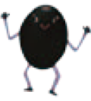 | olive
 | circle | 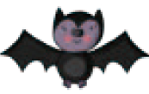 | bat
 | triangle
 | one
 | two

 |  |  | Word List
Class |  |  |  | Name

Lesson 10

Picture | Word | Picture | Word
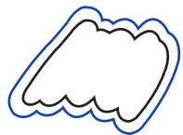 | white |  | one
 | square |  | two
 | rectangle | 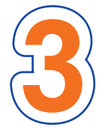 | three
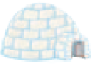 | igloo | 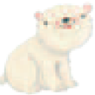 | polar bear

 |  |  | Word List
Class |  |  |  | Name

Lesson 11

Picture | Word | Picture | Word
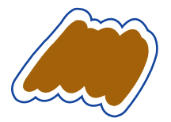 | brown |  | one
 | diamond |  | three
 | star | 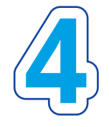 | four
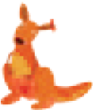 | kangaroo | 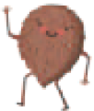 | coconut

 |  |  | Word List
Class |  |  |  | Name

Lesson 12

Picture | Word | Picture | Word
 | one |  | black
 | two |  | white
 | three |  | brown
 | four

 |  |  | Word List
Class |  |  |  | Name

Lesson 13

Picture | Word | Picture | Word
 | blue |  | one
 | brown |  | two
 | green |  | three
 | circle
 | triangle

 |  |  | Word List
Class |  |  |  | Name

Lesson 14

Picture | Word | Picture | Word
 | blue |  | one
 | brown |  | three
 | green |  | four
 | red |  | square
 | rectangle

 |  |  | Word List
Class |  |  |  | Name

Lesson 15

Picture | Word | Picture | Word
 | black |  | two
 | blue |  | four
 | white |  | diamond
 | yellow |  | star
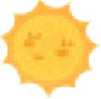 | sun

 |  |  | Word List
Class |  |  |  | Name

Lesson 16 – All Colors

Picture | Word | Picture | Word
 | red |  | purple
 | yellow |  | black
 | blue |  | white
 | orange |  | brown
 | green

 |  |  | Word List
Class |  |  |  | Name

Lesson 16 – All Shapes + Bonus

Picture | Word | Picture | Word
 | circle |  | diamond
 | triangle |  | star
 | square | 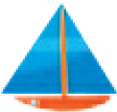 | yacht
 | square | 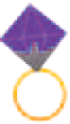 | ring
 | rectangle

