ANSWERS

Hang Out! Plus Student Book 6

Welcome Unit

- Alex, d
- Jenny, f
- Daniel, a
- Li, b
- Mateo, c
- Nadir, e

B.
- Twenty fifteen
- Eighteen twenty-five
- Nineteen sixty-three
- Twenty thirty-six
- Nineteen ten
- Eighteen oh one

C.
- e
- a
- b
- g
- c
- d
- f

D.

- 1674
- 1810
- 1951
- 2001
- 2048

E.
- once a week, once a day
- five times a week
- six times a month
- twice a year
- three times a month

F.
- c
- b
- f
- d
- a
- e

G.
- True
- False
- True
- False

H.
Answers will vary.

C.
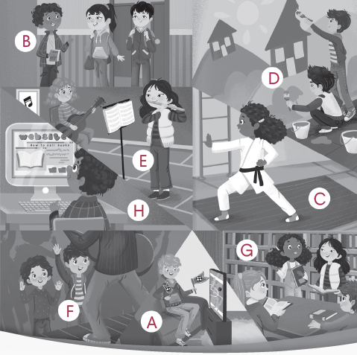

Lesson 2

Reading

B.
  - The purpose of the club is to help their community.
  - The mural shows scenes from the history of Arbordale.
  - Kids from Arbordale Middle School played in the concert.
  - On the website, students put information about the town and important things going on.
  - b

Speaking
Answers will vary.

Lesson 3 Story
Lesson 1
Unit 1

A.

Haven’t you joined a club yet?

You like recording videos, don’t you?

What about the coding club?

You can even develop your own video game.

C.
- b
- b
- c
- a

Expand

B.
- C
- H
- B
- F
- D
- A
- G
- E

C.
- You haven’t recorded a podcast, have you? No, I haven’t.
- You haven’t tried a new recipe, have you? No, I haven’t.
- She is learning photography, isn’t she? Yes, she is.
- He is acting in a play, isn’t he? Yes, he is.
- You haven’t created a playlist, have you? No, I haven’t.
- He/She is taking a first aid course, isn’t he/she? Yes, he/she is.

Lesson 4

Grammar

A.
- Haven’t you done karate?
- Haven’t you gone to a concert?
- Don’t you support a team?
- Haven’t you designed a website?
- Haven’t you painted a mural?
- Don’t you record a podcast?

B.
- You have recorded a podcast, haven’t you?
- He is learning a language, isn’t he?
- She has edited a video, hasn’t she?
- We have gone to a concert together, haven’t we?
- They are taking a first aid course, aren’t they?
- You have created a playlist, haven’t you?

Lesson 5

Writing

A.
Soon, we were hungry and Jocelyn’s mom told us that there was a food stall nearby where we could get some traditional St. Lucian food. I tried green fig and saltfish which is the national dish of St. Lucia. The lady on the stall told me that saltfish is a type of preserved cod. When I took my first bite, I was surprised to find that there were no figs in it at all. The “green figs” are actually green bananas. They are quite hard and not very sweet, but they taste refreshing with the soft, salty, white fish. I loved the pickled peppers in the dish too, which are slightly spicy. It was a perfect combination of delicious ingredients.

B.
Answers will vary.

Lesson 6 CLIL

B.
1. …a more modern style of painting: “cubism,” where the subject, for example, an object, a person, or a landscape, is shown from many angles at the same time.
2. Then, in 1914, World War I began.
3. ….events at which they performed strange songs, poems, plays and dances / a word which had no real meaning

C.
1. d
2. a
3. b
4. c

D.
1. b
2. c
3. a

E.
Answers will vary.

Unit 2

Lesson 1

C.
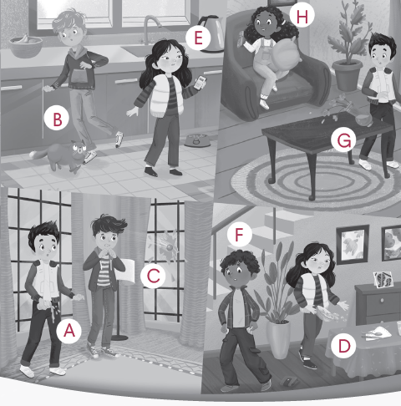

Lesson 2 Reading

B.
- He dropped a whole tray of plates on the floor.
- She stormed out of the restaurant without paying the bill.
- He tripped over his cat.
- He bought her a new flower vase to apologize.
- B

Speaking

Answers will vary.

Lesson 3

Story

A.
- How long have you lived here?
- We have lived in our house since I was born.
- I worked on a project in there for three weeks.
- I’ve just finished working on it.

C.

b

c

b

b

Expand

B.

H

C

G

B

E

F

A

D

C.

How long have you had a broken leg? I have had a broken leg for three weeks.

How long have you had a pet? I have had a pet for two years.

How long have you studied English? I have studied English since 2017.

How long have you played the violin? I have played the violin since 2020.

How long have you known your best friend? I have known my best friend for ten years.

How long have you played lacrosse? I have played lacrosse since 2022.

Lesson 4

Grammar

A.
- I have just dropped my phone on the ground.
- She lost her car keys yesterday.
- They have just broken the window by accident.
- We have just spilled all the marbles on the ground.
- I knocked over the lamp on the table, and it broke.
- I found my wallet underneath the couch.

B.
- known, since
- played, for
- have been, for
- have played, since
- has studied, since
- have had, for

Lesson 5

Writing

A.

Answers will vary.

Sample Answer:

When my son was eight, we went to ride in a place called Navajo Rocks where a trail goes over beautiful orange rocks. The trail is steep, so he followed me as I showed him the way. He pulled too hard on the brakes, the bike suddenly tipped up, and he flew over the handlebars. He landed with a crash on a hard rock and was in a lot of pain. Of course, he was wearing a helmet, but it turned out he had broken his arm.

B.

Answers will vary.

Lesson 6

CLIL

B.
- geography
- across the Malacca Strait, near Sumatra, Indonesia
- huge waves hit 14 countries

C.
- c
- d
- d
- b

D.
1. a
2. c
3. b

E.
Answers will vary.

Review 1 (Units 1-2)

A.

language

concert

design

mural

spill

knock over

find

trip

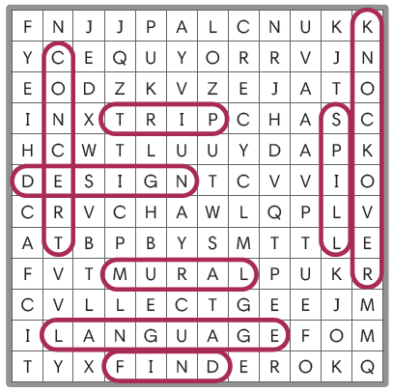

B.
- b
- b
- a
- b

C.

finded found

have haven’t

play played

dropping dropped

D.
- I spilled my tea on my brand-new T-shirt.
- Don’t you support your local football team every week?
- They have been recording a podcast together for five years.
- The kids have just smashed the window with a baseball.
Unit 3

Lesson 1

C.

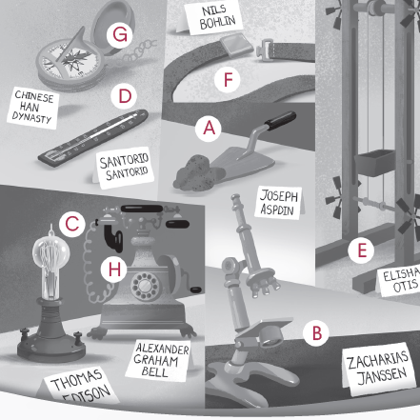

Lesson 2

Reading

B.
  - It is used to find direction.
  - Otis invented the first modern elevator.
  - It allowed people to build very tall buildings.
  - They could discover tiny living things called microorganisms.
  - b

Speaking
A.
Q1: Who invented the TV?
A1: The TV was invented by Lougie Baird.
Q2: Who invented the laptop?
A2: The laptop was invented by Adam Osborne.
Q3:Who invented the airplane?
A3: The airplane was invented by the Wright brothers.
Q4: Who invented the car?
A4:The car was invented by Karl Benz.

Lesson 3 Story

A.
- Do you know how we can get to the Eiffel Tower, Li?
- When were compasses invented?
- We have been walking for almost an hour.

C.
- b
- a
- b
- c

Expand

B.
- G
- C
- E
- A
- D
- H
- B
- F

C.
- When was oxygen discovered? It was discovered in 1772.
- When was Pluto discovered? It was discovered in 1930.
- When were X-rays invented? They were invented in 1895.
- When was the Empire State Building built? It was built in 1931.
- When was the Taj Mahal built? It was built in 1643.
- When was the Golden Gate Bridge built? It was built in 1937.

Lesson 4

Grammar

A.
- The microscope was invented by Zacharias Janssen in 1590.
- Gravity was discovered by Issac Newton in 1666.
- Easter Island was visited by Jacob Roggeveen in 1772.
- The violin was created by Andrea Amati in the 1500s.
- Mount Everest was climbed by Edmund Hillary in 1953.
- The Mona Lisa was painted by Leonardo Da Vinci in the 16th century.

B.
- When was the Golden Gate Bridge built?
- When was the Taj Mahal finished?
- When was Pluto discovered?
- When was the airplane invented?
- When was the first video game played?
- When was the first suit made?

Lesson 5

Writing

Answers will vary.

Lesson 6

CLIL

B.
- people had to walk or use wagons.
- Automobiles, more commonly known as cars
- the early 1900s

C.
- c
- d
- a
- c

D.
- c
- c
- b

E.
Answers will vary.
Unit 4

Lesson 1

C.
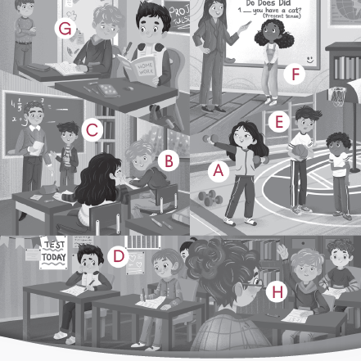

Lesson 2

Reading

B.
  - He was playing soccer with Daniel all weekend.
  - Jenny told Alex to go to the teacher and tell the truth.
  - He is usually respectful of the teacher.
  - Alex thinks she will give him a failing grade.
  - a

Speaking
Answers will vary.

Lesson 3 Story

A.
- I can’t wait to go to the movies with everyone tomorrow.
- I can’t go with you this time, I’m afraid.
- Did you copy someone’s homework?
- If I had studied, I would have gotten good grades on the science exam!

C.
- c
- a
- a
- b

Expand

B.
- H
- F
- D
- G
- C
- B
- A
- E

C.
- They should have trained more. Right, if they had trained more, they would have won an award.
- He shouldn’t have gossiped.--> If he hadn’t gossiped, they wouldn’t have fought.
- She shouldn’t have cheated on a test. Right, if she hadn’t cheated, she wouldn’t have failed the exam.
- They shouldn’t have copied someone’s homework. If they hadn’t copied someone’s homework, they wouldn’t be grounded.
- She should have told the truth. If she told the truth, she would not have been punished.
- He should have asked for permission. Right, if he had asked for permission he would not have been punished.

Lesson 4 Grammar

A.
- You should have asked for permission.
- You should have gotten good grades.
- I should not have cheated on the test.
- She should have told the truth.
- He should have said sorry.

B.
- If he had studied, he would have gotten good grades.
- If you had told the truth, you would not have felt guilty.
- If I had been respectful, I would not have been grounded.
- If she had copied someone’s homework, she would have gotten detention.
- If we had said sorry, we would not have fought.

Lesson 5

Writing

A.
Answers will vary.
Sample Answer:
The writer believes that while AI can be efficient for simple tasks, it hinders students' ability to develop their own ideas, which is a crucial part of learning. Additionally, the writer warns that AI is programmed by humans with their own biases, so students should be cautious about blindly trusting the information AI provides.

B.
Answers will vary.

Lesson 6 CLIL

B.
- $3,000 in today’s money
- the Carpathia
- However, the Titanic only had 20 lifeboats

C.
- c
- d
- c
- d

D.
1. a
2. b
3. b

E.
Answers will vary.

Review 2 (Units 3-4)

A.
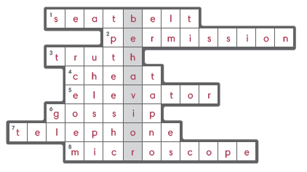
Secret Word: behavior

B.
- a
- a
- b
- a

C.
- build built
- go gone
- would would have
- created created by

D.

The piano was invented in 1700.

He should have said sorry.

If she had cheated on the test, she would have failed the exam.

The Notre Dame was built in 1345.
Unit 5

Lesson 1

C.

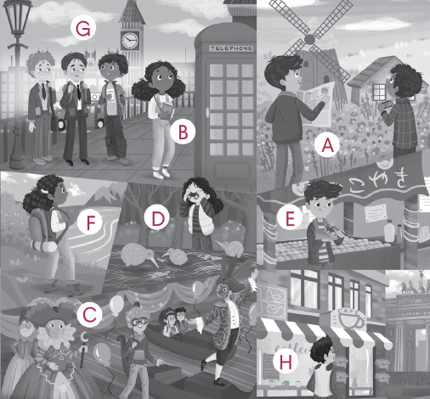

Lesson 2

Reading

B.
1. La Rambla is the best place to explore.
2. You can experience opera, ballet, plays, orchestra performances, and art galleries there.
3. You can swim in the Mediterranean.
4. You should sample tapas or paella.
5. c

Speaking
Answers will vary.

Lesson 3 Story

A.
- I plan to backpack in the mountains and experience the culture.
- You should be careful, Daniel.
- It’s important to remember that every country is different.
- Ruining tourist destinations is a big problem, too.

C.
- c
- b
- c
- a

Expand

B.
- E
- D
- G
- H
- B
- C
- A
- F

C.
- What is a problem with overtourism? Poaching is an issue.
- What is a problem with overtourism? Disrespecting local customs is a problem.
- What is a problem with overtourism? Overcrowding can cause problems.
- What is a problem with overtourism? Ignoring warnings is an issue.
- What is a problem with overtourism? Ruining tourist destinations is an issue.
- What is a problem with overtourism? Destroying nature can cause problems.

Lesson 4 Grammar

A.
- I plan to travel to Europe next year.
- They decided to go backpacking around Thailand.
- We expect to wander around the town.
- She hopes to sample the food.
- He wants to take in the sights.

B.
- Wasting natural resources damages the environment.
- Ignoring warnings at tourist sites is dangerous.
- Poaching animals is illegal.
- Ruining tourist destinations while you are visiting a new place is awful.
- Not destroying nature while you hike is important.
- Endangering animals at parks and in the wild is harmful.

Lesson 5

Writing

A.

Another problem with overtourism is the urbanization of smaller towns and villages. As a new destination becomes popular, local businesspeople build more hotels, shops, and restaurants. Tourists also create large amounts of waste, trash, and transport pollution. In places like Bali, this has led to the destruction of natural areas and habitat loss for local wildlife. To create healthy tourism, governments need to limit construction. People should also carefully consider where they choose to visit.

B.

Answers will vary.

Lesson 6 CLIL

B.
- Maasai
- at the airport, tourists pay an entrance fee of $100
- the beautiful Scottish Highlands

C.
- c
- c
- d
- d

D.
- b
- c
- c

E.
Answers will vary.
Unit 6
Lesson 1

C.
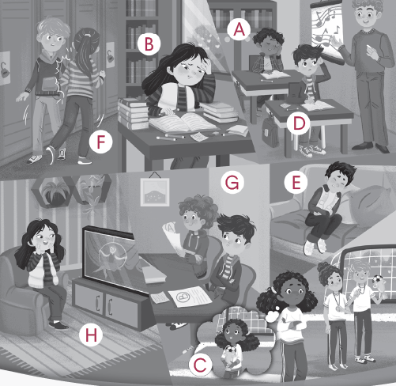

Lesson 2
Reading

B.
  - He is on vacation with his aunts, uncles, and cousins.
  - His family canceled their trip to the amusement park.
  - He hurt his ankle.
  - He is studying math.
  - b

Speaking

B.
Answers will vary.

Lesson 3 Story

A.
- You must be exhausted.
- I’m glad to hear it.
- You must be disappointed when you lose a big game.
- What is your favorite team?

C.
- a
- b
- c
- b

Expand

B.
- E
- D
- C
- H
- A
- F
- B
- G

C.
- She cheated on a test. She must have been ashamed.
- She went on a vacation. It must have been relaxing.
- She went to the aquarium. It must have been fascinating.
- She got good grades. She must have been satisfied.
- He fell from a chair. It must have been shocking.
- They watched a horror movie. It must have been terrifying.

Lesson 4 Grammar

A.
- She must be excited.
- You must be nervous.
- He must be exhausted.
- She must be amusing.
- She must be embarrassed.

B.
- You must have been impressed.
- It must have been shocking.
- It must have been relaxing.
- He must have been ashamed.
- It must have been painful.

Lesson 5

Writing:

In terms of animation, Pixar has created an incredible movie. The bright colors are wonderful, and the new characters are very entertaining. Embarrassment, who hides inside a big hoodie, is the funniest character in the film. It is unfortunate that he doesn’t appear in the film more. Anxiety is a less enjoyable character and looks as though she comes from another film. However, this may

just be a clever decision from the director, as anxiety is such a new and strange feeling for Riley.

B.

Answers will vary.

Lesson 6 CLIL

B.
- Scottish
- the first outdoor clay ovens appeared around 4,000 years ago in the Middle East.
- One of these was the Royal Game of Ur

C.
- c
- b
- a
- b

D.
- b
- b
- b

E.
Answers will vary.

Review 3 (Units 5-6)

A.
Across:
1. jealous
3. take in the sights
7. painful
8. exhausted

Down:
2. offensive
4. sample the food
5. wander around
6. go backpacking

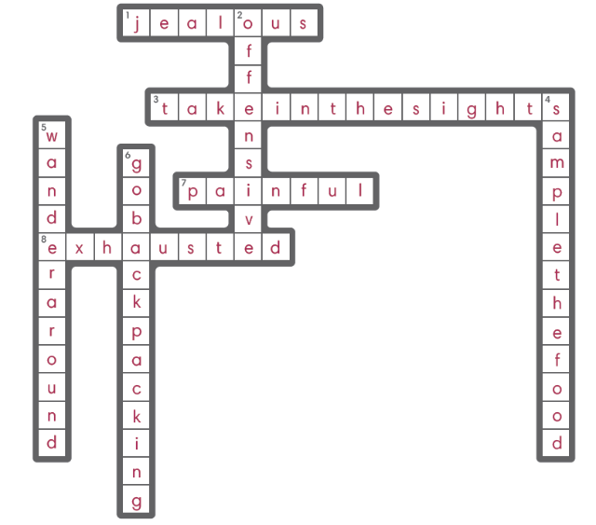

B.
- a
- b
- b
- a

C.
- giving to give
- is be
- must must be
- Cook Cooking

D.

1. Poaching, endangering

2. laughing, amusing

3. warnings, resources

4. must, relaxing
Unit 7

Lesson 1

C.

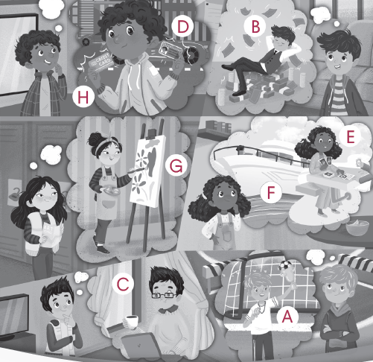

Lesson 2

Reading

B.
- He wishes he were older.
- He only enjoys computer class.
- He wished he had a job.
- He wishes he were retired.
- c

Speaking

Answers may vary.

Lesson 3 Story

A.
- If I were older, I would never have to do homework again.
- You could shop online and buy whatever you like!
- If I were wealthy, I would buy a yacht and sail around the world with all my friends!

C.
- a
- b
- b
- b

Expand

B.
- E
- B
- C
- G
- F
- A
- H
- D

C.
1. What would you do if you were older? If I were older, I would apply for a job.
- What would you do if you had a credit card? If I had a credit card, I would shop online.
- What would you do if you were retired? If I were retired, I would volunteer.
- What would you do if you had a yacht? If I had a yacht, I would sail around the world.
- What would you do if you had a driver’s license? If I had a driver’s license, I would offer rides.
- What would you do if you were creative? If I were creative, I would record an album.

Lesson 4 Grammar

A.
- am were
- wish wishes
- have had
- were had
- was were
- wishes wish

B.
- If she had a yacht, she would sail around the world.
- If I were talented, I would record an album.
- If he had a driver’s license, he would drive himself to school.
- If he were creative, he would make a painting.
- If I were wealthy, I would buy a house.
- If she were older, she would apply for a job.

Lesson 5

Writing

A.
Currently, I live in Buffalo Grove, Illinois, a suburb of Chicago, USA. It is a convenient place to live as we can get to the city easily. We can also reach the countryside easily as well, but it is quite flat. In the winter, it is very cold here, and we often struggle to get to school because of deep snow. We have lakes here, but we are a long way from the sea. In my dream life, I would live in Myrtle Beach, South Carolina, USA. It is right next to the sea, and it is warm most of the year, without much snow at all! Inland, there are the Blue Ridge Mountains, which are beautiful.

B.

Answers will vary.

Lesson 5

CLIL

B.

Slocum took his
- boat, the Spray
- She was aged just 16 when she completed the journey in 2010.
Jeanne Socrates was 77 years old when she took her boat, the SV Nereida, around the world alone in 2019.

C.
- a
- d
- c
- c

D.
1. b
2. a
3. b

E.

Answers will vary.

Unit 8

Lesson 1

C.

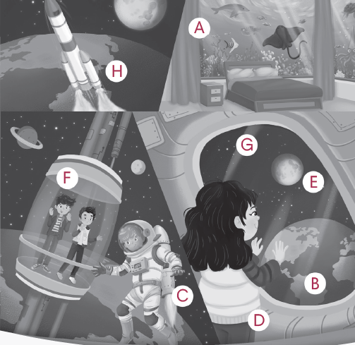

Lesson 2

Reading

B.
1. It is people paying to travel into outer space.
2. They can see Earth from far away, float without gravity, and be amazed by how big space is.
3. It can inspire science / make technology better / pay for more space exploration.
4. It is bad for the environment and dangerous.
5. b

Speaking

Answers will vary.

Lesson 3 Story
A.
- This science museum is fascinating!
- How will we travel there?
- We will bring seeds from Earth and grow our own food on Mars.
- Will we see holograms to speak to people on the surface?

C.
- b
- a
- a
- c

Expand

B.
- B
- A
- G
- H
- C
- E
- D
- F

C.
- Will we live in very tall towers in 2050? Yes, we will / No, we won’t.
- Will we fly drones in 2035? Yes, we will / No, we won’t.
- Will we use holograms in 2045? Yes, we will / No, we won’t.
- Will we charge our cars in 2040? Yes, we will / No, we won’t.
- Will we own robots in 2060? Yes, we will / No, we won’t.
- Will we have virtual schools in 2030? Yes, we will / No, we won’t.

Lesson 4 Grammar
A.
- How will we travel? We will use jet packs.
- Where will we live? We will live in very tall towers.
- Where will we travel? We will travel to the moon.
- What school will we go to? We will go to virtual school.
- What will we own? We will own robots.

B.
- Will we travel through time? No, we won’t.
- Will we have AI friends? Yes, we will.
- Will we use holograms? Yes, we will.
- Will we charge our cars? No, we won’t.
- Will we own robots? No, we won’t.

Lesson 5

Writing

A.
- 2050
- AVs
- 7 billion hours
- 50 minutes
- AAVs
- drones

B.
Answers will vary.

Lesson 6

CLIL

B.
1. cans of edible paste or gel are put into the printer
2. US space agency NASA has been a leader in developing the technology.
3. you won’t find a 3D food printer in your kitchen any time soon.

C.
- b
- c
- a
- c

D.
- c
- b
- a

E.
Answers will vary.

Review 4: Units 7-8

A.

credit card

space

talented

yacht

moon

underwater

rocket

retired

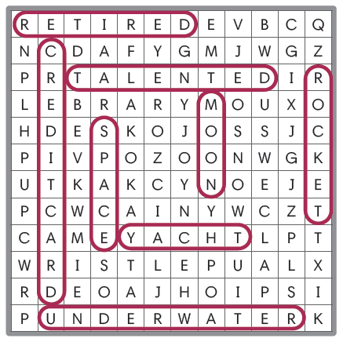

B.
- b
- b
- b
- a

C.
- wishes wish
- would will
- will would
- no yes OR will won’t

D.

Answers will vary.

Unit 9

Lesson 1

C.
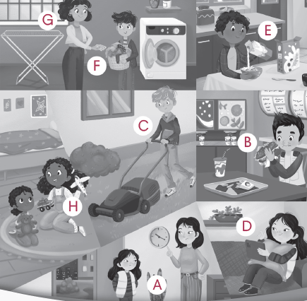

Lesson 2

Reading

B.
  - They have to mow the lawn, prepare their breakfast, and do their own laundry.
  - Alex’s curfew is seven o’clock.
  - Hisa family usually has healthy meals at home.
  - His parents think it is important to balance screen time with other activities.
  - b

Speaking
Answers will vary.

Lesson 3 Story

A.
- I just got my picture taken on a ride.
- He lets me get an allowance, but only if I work for it.
- She makes me look after my siblings on the weekend.
- I’m a little overwhelmed.

C.
- c
- c
- b
- a

Expand

B.
- G
- A
- D
- E
- F
- C
- B
- H

C.
- What happened to him? He got his eyes checked.
- What happened to them? They had their picture taken.
- What happened to her? She had her wallet stolen.
- What happened to him? He got his hair cut.
- What happened to you? I had my phone repaired.
- What happened to you? I got my clothes dry cleaned.

Lesson 4 Grammar

A.
- My parents let me eat fast food.
- My mom makes me look after my siblings.
- My grandparents have me prepare my own breakfast.
- My dad makes me mow the lawn.
- My grandparents let me use my tablet.

B.
- I had my eyes checked.
- I got my hair cut.
- I had my clothes dry cleaned.
- I got my picture taken.
- I had my tooth removed.
- I got my leg broken.

Lesson 5

Writing

A.
The second problem with school uniforms is that they are expensive to buy.
Children grow fast and parents have to spend too much money on uniforms.
Also, we can only wear them at school, so they are not good value. Some parents
and teachers say that students behave better when they wear uniforms. In fact,
uniforms are becoming more popular in schools. However, studies have shown
that they have no effect on student behavior.

B.
Answers will vary.

Lesson 6 CLIL
B.
1. Once chosen, these people meet in the Senate and the House to debate and vote.
- They have the power to cancel, or “veto,” the laws written in Congress.
- Judges of the Supreme Court, or “justices,”

C.
- d
- b
- c
- c

D.
- c
2. b
3. c

E.
Answers will vary.

Unit 10

Lesson 1

C.

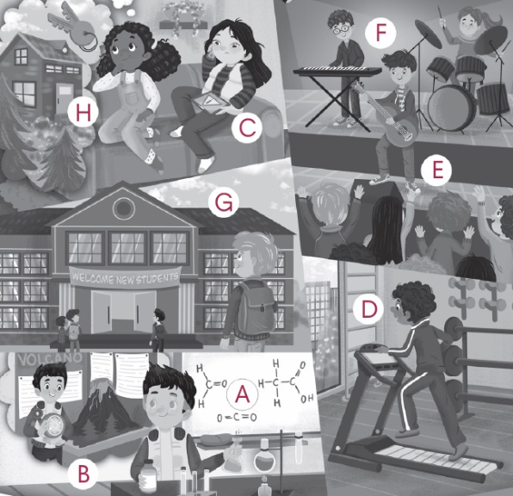

Lesson 2

Reading

B.
- She plays the flute.
- Her favorite subject is English.
- They will travel to a cabin in the mountains.
- Have cozy evenings by the fireplace.
- a

Speaking

Answers will vary.

Lesson 3

Story

A.
- Time goes by so quickly!
- What do you think you will do when you’re older?
- I hope I will be leading a band.
- Contacting the service center for his broken laptop!

C.
- a
- c
- c
- a

Expand

B.
- E
- D
- A
- F
- C
- H
- B
- G

C.
- What do you think/hope you will be doing in five years? I think/hope I will be developing content.
- What do you think/hope you will be doing in ten years? I think/hope I will be touring the world.
- What do you think/hope you will be doing in five years? I think/hope I will be celebrating my graduation.
- What do you think/hope you will be doing in fifteen years? I think/hope I will be creating an app.
- What do you think/hope you will be doing in twenty years? I think/hope I will be assisting the elderly.
- What do you think/hope you will be doing in ten years? I think/hope I will be earning a big salary.

Lesson 4

Grammar

A.
- I will be developing content.
- I will be leading my band.
- I will be working out.
- I will be attending school.
- I will be contacting a service center.

B.
- I think I will be assisting the elderly.
- I hope I will be earning a big salary.
- I guess I will be participating in a contest.
- I believe I will be touring the world.
- I think I will be renting a cabin.
- I believe I will be creating an app.

Lesson 5

Writing

A.

I will train every day by running.

I will practice three times a week with my team.

I will play games and help my team win.

B.

Answers will vary.

Lesson 6

CLIL

B.

1. In the 1950s, as air travel developed, pilot became a popular option.

Many create content focusing on a hobby or teach their viewers new skills.
- famous sports players or TV stars

C.
- d
- d
- c
- a

D.

a

a

c

E.

Answers will vary.

Review 5 (Units 9-10)

A

Across:

1. lead my band

5. do experiments

6. use my tablet

7. eat fast food

8. mow the lawn

Down:

2. attend school

3. have a curfew

4. workout

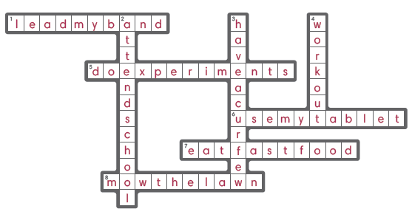

B.
- a
- b
- a
- a

C.
- create creating
- checking checked
- prepared prepare
- am be

D.
- My mom had her phone repaired after she cracked the screen.
- In twenty years, I believe I will be earning a big salary at a famous company.
- My parents have me look after my siblings every day after school / after school every day.
- I hope I will cure a disease at my dream job.

