ANSWERS

Hang Out! Plus Workbook 5

Welcome

- Daniel
- Jenny
- Alex
- Mateo
- Li
- Nadir

B.
- the USA
- June 3rd
- PE
- reading comic books
- creative
- France

C.
- Australia
- Ecuador
- UK
- Brazil
- Thailand
- Canada
- Malaysia
- Morocco
- Nigeria
- USA
- Germany
- Italy

D.
- Australia, Brazil, Malaysia, Morocco, and the USA
- Ecuador, Thailand
- Malaysia, Brazil, and Ecuador

E.
- Jenny, Nadir
- November 7th, March 3rd
- Italy, Malaysia
- patient, easygoing
- math, science
- catching butterflies, playing rugby

F.

watching quiz shows

September 22nd

outgoing

Chile

geography

G.
- d
- c
- e
- b
- a
- f

H.
- what’s
- from
- hobby
- video games
- April

Unit 1: Future Plans

A.
1. homework
2. blog
3. housework
4. run
5. soccer
6. gymnastics
7. golf
8. friend

I’m checking my homework.

I’m blogging.

I’m doing housework.

I’m going for a run.

I’m watching a soccer game.

I’m going to gymnastics.

I’m golfing.

I’m helping out a friend.

C.
- a
- b
- b
- a

D.
  - blog
  - check, homework
  - golf
  - do, housework
  - help, a friend
  - go, for a run

Listening

A.
1. going to gymnastics (picture 3)
2. doing housework (picture 2)
3. checking my homework (picture 4)
4. golfing (picture 1)

B.
1. d
2. b
3. a
4. c
5. f
6. e

C.
1. doing housework
2. helping a friend
3. They’re going to gymnastics on Tuesday.
4. They’re golfing on Sunday.

Writing

A.
- Layla
- Vanessa
- Johnny
- George
- Heath
- Anna

B.
Answers will vary.

Vocabulary

A.
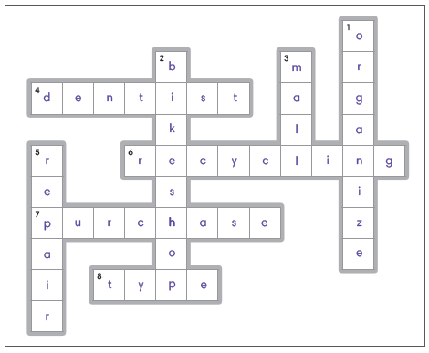

Down:
1. organize
2. bike shop
3. mall
5. repair

Across:
4. dentist
6. recycling
7. purchase
8. type

Speaking

A.
1. need to
2. needs to
3. dentist
4. recycling center

Grammar

A.

1. going for a run

2. blogging

3. helping out a friend

4. They are doing housework tonight.

5. He is watching a soccer game tomorrow.

B

1. needs à need

2. is needingà needs

3. need à need to

4. typing à type

5. needs à need

CLIL

B
1. False
2. True
3. True
4. False
5. False
6. False

Reading & Writing

A.
- typing a paper
- checking my homework
- do housework
- going for a run
- repair his glasses
- going to the recycling center
- go to the bike shop
- going to the mall

B.
- b

C.
- F
- T
- T

Unit 2: Thinking about the Past

A.
- develop
- stamps
- deliver
- silent
- record
- tapes
- payphones
- address

B.
- use
- play
- develop
- record
- deliver
- watch

C.
1. True
2. False
3. False
4. True
5. False
6. True
7. False
8. True

D
- used to use
- used to record
- used to play
- used to keep
- used to watch
- used to deliver
- used to collect
- used to develop

Listening

A.
- False
- True
- False
- True
- False
- True

B.

a

b

b

b

C.
- when they were younger
- used to
- use to
- record videos
- used to

Writing

A.
- used
- keep
- used to
- used to collect
- used
- did / used to

B.
Answers will vary.

Vocabulary

A.
- feed, siblings
- take naps
- catch butterflies
- crawl
- name toys
- fall down
- cry a lot
- babysitter
Q: What did your brother use to do when he was younger?
A: He used to eat his toys!

Speaking

A.
- didn’t
- use to
- fall
- used to

Grammar

A.
- Tim used to collect stamps.
- Mom used to record videos.
- Aunt Helen used to develop photos.
- He used to deliver newspapers.

B.
- Did your mom use to catch butterflies
- use to deliver newspapers when he was young?
- I didn’t use to have a babysitter
- Did you use to fall down a lot when you were young?

CLIL

B.
1. from stone tablets
2. at the city center
3. the printing press
4. on the radio
5. the first TV news broadcast
6. on the internet

Reading & Writing

A.
- record videos
- crawl
- play cassette tapes
- fall down
- cry a lot
- deliver newspapers
- keep an address book
- take naps

B.
- b

C.
- F
- F
- T

Unit 3: Getting a Pet

A.
- lizard
- hamster
- kitten
- turtle
- parrot
- goldish
- snake
- rabbit

B.
- hamster
- would rather
- than
- get
- parrot
- Answers will vary.

C.
1. c
2. b
3. d
4. a
5. h
6. g
7. f
8. e

D.
1. would rather
2. than
3. would rather get
4. get a parrot

Listening

A.
- T
- F
- T
- F
- T

B.
- c
- e
- b
- a
- d

C.
- would rather get
- than
- than a rabbit
- get a snake
- I would rather get a turtle

Writing

    - goldfish than a hamster
    - rabbit than a snake
    - snake than a lizard
    - lizard than a kitten
    - parrot than a kitten

Answers will vary.

Vocabulary

- c
- d
- h
- e
- g
- b
- f
- a

- soft
- friendly
- cute
- active
- quiet
- clever
- playful
- easy to care for

Speaking

A.
1. hamster (picture 2)
2. kitten (picture 2)
3. lizard (picture 1)
4. parrot (picture 2)

Grammar

A.

Joe would rather have a rabbit than a hamster.

My sister would rather have a parrot than a turtle.

I would prefer a kitten to a goldfish because it is cute.

He would rather have a lizard than a snake.

B.
- a lizard, turtle
- prefer a kitten to a snake, is playful
- would prefer a goldfish to a parrot because it is / they are quiet
- would prefer a hamster to a snake because it is / they are active

CLIL

B.
1. mullet
2. safer
3. shark
4. dolphins
5. 1960
6. guarded

Reading & Writing

A.
- soft
- playful
- clever
- goldfish
- quieter
- turtle
- more active
- easy to care for

B.
- a

C.
- c, Fred
- c, quiet
- c, vegetables

Unit 4: Helping at Home

A.
- do the dishes
- sweep the floor
- feed the cat
- clean the windows
- water the plants
- mop the floor
- take out the trash
- set the table

B.
- set the table
- taken out the trash
- fed the cat
- done the dishes
- swept the floor
- watered the plants
C.
1. she hasn’t done it yet
2. he hasn’t done it yet
3. they have already done it
4. she has already done it
5. cleaned the windows
6. watered the plants
7. set the table yet
8. swept the floor yet

D.
1. fed
2. mopped
3. hasn’t
4. swept
5. haven’t

Listening

A.
1. a
2. a
3. b
4. b
5. b

B.
- fed the cat
- already done it
- Have you swept
- Have you cleaned
- done it yet

Writing

A.

they haven’t done it yet.
- he has already done it
- watered the garden yet
- Has she swept the floor yet?

B.

already done

haven’t done

Have

Have they mopped

Vocabulary

A.

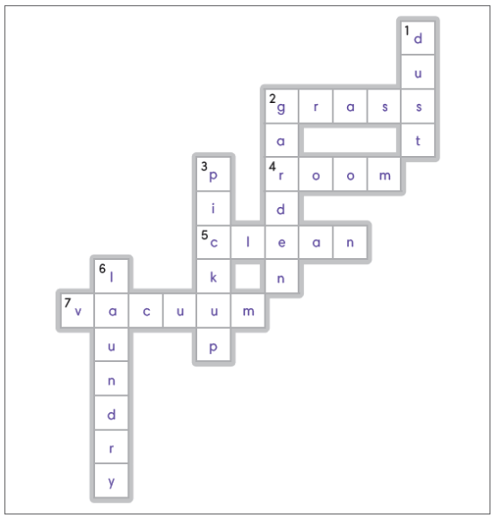
Across:
1. grass
4. room
5. clean
7. vacuum
Down:
1. dust
2. garden
3. pick up
6. laundry

Speaking

A.
- b
- e
- c
- d
- a

Grammar

A.
- No, they haven’t done it yet.
- Yes, I have already done it.
- No, I haven’t done it yet.
- Yes, he has already done it.

B.
- No, no one has done it yet.
- Has anyone cut the grass yet? / has already done it.
- has already done it
- Has anyone picked up the toys yet? / no one has done it yet.

CLIL

B.
1. False
2. True
3. False
4. True
5. False
6. True

Reading & Writing

A.
- cleaned the windows
- cut the grass
- water the plants
- picked up the toys
- feed the cat
- swept the floor
- clean the bathroom
- take out the trash

B.
- a

C.
1. False
2. False
3. True

Unit 5: A School Competition

A.
- high jump
- long jump
- event
- competition
- hurdles
- marathon
- race
- prize

B.

never

have never

has run

have run

has never won

C.
1. False
2. True
3. True
4. False

D.
1. I have never run the hurdles.
2. They have competed in a race.
3. She has never lost the long jump.
4. He has won a prize.
5. Mark has never tied a marathon.

Listening

A.
1. b
2. a
3. a
4. a
5. a
6. b

B.
1. competed in
2. won
3. won
4. never tied
5. has run

C.
1. never won a prize
2. have never done
3. have done
4. have never run the hurdles
5. I have never lost a race

Writing

    - he hasn’t
    - lost a race
    - won a prize
    - he has
    - competed in a marathon

B.
Answers will vary.

Vocabulary

- javelin
- relay
- shot put
- pole vault
- field hockey
- handball
- badminton
- rugby
A: It doesn’t matter if you win or lose as long as you try your best!

Speaking

A.
- competed
- have competed
- played
- three

Grammar

A.
- I have taken part in a competition.
- I have never lost an event.
- Yes, I have played field hockey many times.
- No, I have never run a marathon.

B.
- I have never
- Have you ever done / I have done the pole vault
- Have you ever played badminton? / never played
- Have you ever played field hockey? / Yes, I have played, times

CLIL

B.
1. ten
2. 1,500 meters
3. exhausted

C.
  - discus
  - hurdles
  - pole vault

Reading & Writing

A.
- took part
- relay
- ran the hurdles
- tied the race
- badminton
- rugby
- handball
- won a prize

B.
- c

C.
- c
- a
- b

Unit 6: Our Environment

A.
- endangered animal
- noise
- clean air
- Pollution
- garbage
- trash cans
- traffic jam
- green areas

B.
- too much
- not enough
- are too many
- is too much
- are not enough
- are too many
- is not enough
- is too much

C.
1. False
2. False
3. False
4. True

D.
1. not enough
2. There is
3. too much
4. trash cans
5. too much
6. too many

Listening

A.
1. too many
2. not enough
3. too much
4. too much
5. not enough
6. too many

B.
1. False
2. True
3. True
4. False
5. True
6. True

C.
1. b
2. d
3. c
4. a

Writing

A.
- is, There are too many cars.
- many, There is too much garbage.
- not enough, There are too many endangered animals.
- are, There is not enough clean air.
- are, There is too much noise.

B.
Answers will vary.

Vocabulary

A.
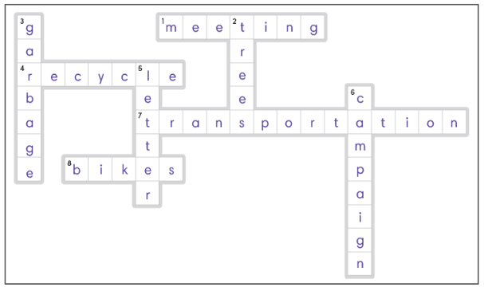
Across:
1. meeting
4. recycle
7. transportation
8. bikes

Down:
2. trees
3. garbage
5. letter
6. campaign

Speaking

A.
- c
- d
- b
- a

Grammar

A.
- too much
- too much
- not enough
- too many

B.
Answers will vary.

CLIL

B.
- f
- c
- e
- b
- d
- a

Reading & Writing

A.
- Pollution
- clean air
- traffic jams
- ride bikes
- take public transportation
- endangered animals
- green areas
- write letters

B.
- a

C.
- green areas
- slow
- writing letters

Unit 7: This Weekend

A.
- rainy
- chilly
- stormy
- sunny
- guitar
- yard
- tablet
- picnic

B.
- he’ll play
- it’s
- she’ll practice
- it’s
- this weekend

C.
1. d
2. c
3. b
4. a

D.
1. If it’s
2. he’ll play
3. go on a picnic
4. she’ll practice

Listening

A.
- a
- b
- a
- b
- a
- b

B.
- b
- a
- c
- d

C.
1. it’s sunny this weekend
2. go on a picnic
3. we’ll play in the yard
4. if it’s stormy
5. I’ll practice the guitar

Writing

A.
- play in the yard
- play on her tablet
- listen to music
- go on a picnic together
- watch movies

B.
Answers will vary.

Vocabulary

A.
1. e
2. g
3. a
4. h
5. d
6. f
7. b
8. c

B.
1. do homework
2. is cool
3. visit the library
4. boiling
5. go swimming
6. go to the park
7. snowy
8. freezing

Speaking

A.
- Yes, I will.
- No, I won’t.
- Yes, we will.
- Yes, we will.

Grammar

A.
- If it is sunny this weekend, I will go to the park.
- If it is stormy tomorrow, I will stay home and play on the tablet.
- If it is chilly tomorrow, I will wear a hat and scarf.
- If it is sunny next weekend, I will play in the yard.

B
- to the park if it is
- Will you play soccer if it is
- Will you go swimming if it is
- Will you visit the library if it is

CLIL

B.

False

True

True

C

thick

hotter

coat

Reading & Writing

A.
- sunny
- go on a picnic
- go swimming
- go to the park
- freezing
- snowy
- practice the guitar
- do our homework

B.
- c

C.
- b, go swimming
- c, the park
- b, a hat

Unit 8: An Exciting Basketball Game

A.
- receive a trophy
- interview
- celebrate
- discuss
- warm up
- films
- take a break
- cheers

B.
- interviewing
- taking a break
- discussing
- warming up
- cheering
- filming

C.
1. False
2. True
3. False
4. False

D.
1. were
2. celebrating
3. was filming
4. were receiving
5. taking a break
6. cheering

Listening

A.
- 4:00 p.m.
- 3:00 p.m.
- 4:30 p.m.
- 3:45 p.m.
- 3:15 p.m.
- 3:45 p.m.

B.
- warming up
- At 3:15
- father
- cheering
- 4:30 p.m.

C.
- d
- e
- b
- a
- c

Writing

A.
- were
- warming
- were
- was
- was doing

B.
Answers will vary.

Vocabulary

A.
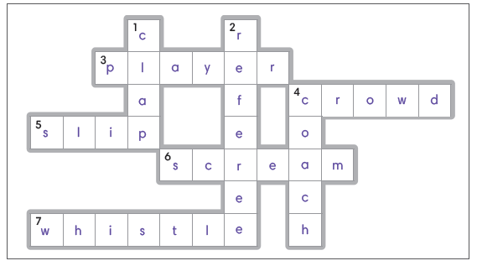
Across:
3. player
4. crowd
5. slip
6. scream
7. whistle

Down:
1. clap
3. referee
4. coach

Speaking

A.
- running
- screamed
- was winning
- slipped

Grammar

A.
- doing an interview
- were receiving a trophy at 12:15
- was discussing a plan at 9:30
- Allie was warming up at 8:45

B.
- The referee was blowing the whistle when the fans screamed.
- The coach was clapping when the player slipped.
- The coach was clapping when the crowd screamed.
- The player was slipping when the referee blew the whistle.

CLIL

B.
1. False
2. False
3. True
4. True
5. True
6. True

Reading & Writing

A.
- warm up
- coach
- referee
- slipped
- cheering
- filming
- celebrated
- received a trophy

B.
- b

C.
- F
- F
- T

Unit 9: Many Things from Many Places

A.
- sandals
- salmon
- candle
- digital camera
- PC
- coconuts
- pineapples
- flute

B.
- salmon
- flute
- PC
- digital camera
- candle
- sandals
- pineapple
- coconut

C.
1. True
2. False
3. True
4. False
5. True
6. False

D.
- are / The coconuts are grown
- are / The pineapples are grown
- Where are the salmon / The salmon are fished
- Where are the candles made? / The candles are made in the USA.

Listening

A.
1. is made in
2. is from
3. are from
4. are from
5. Where are they from?
6. are made in

B.
1. is made
2. is made
3. are grown
4. are from Singapore
5. Where are
6. is fished

Writing

A.
1. are made in
2. is grown
3. is made
4. is from
5. are grown in
6. from

B.
Answers will vary.

Vocabulary

A.
- f
- gs
- a
- h
- c
- b
- d
- e

B.
- souvenir
- trumpet
- suitcase
- smartphone
- uniform
- skis
- curtains
- umbrella

Speaking

A.
- Yes, they are.
- No, it isn’t.
- That uniform is from Chile, isn’t it?
- Those curtains are made in Greece, aren’t they?

Grammar

A.
- The sandals are made in Bolivia.
- This pineapple is grown in Malaysia.
- The flute is made in the Netherlands.
- The salmon is / are fished in Japan.

B
- isn't it / Yes, it is.
- aren’t they / No, they aren’t.
- is made, isn’t it / Yes, it is.
- aren’t they / No, they aren’t.

CLIL

B.
1. small
2. deliver
3. enormous
4. grown
5. fresh
6. Online

Reading & Writing

A.
- suitcase
- salmon
- coconut
- curtains
- digital camera
- sandals
- umbrella
- souvenir

B.
- a

C.
- fish
- curtains
- pictures

Unit 10: Helping the Community

A.
- clean up beaches
- help the homeless
- visit elderly people
- collect money
- organize food drives
- donate clothes
- holds bake sales
- volunteer at an animal shelter

B
- she donated clothes
- that she organized food drives
- that he held bake sales
- that he volunteered at an animal shelter
- said that she helped the homeless

C.
- True
- False
- False
- True
- False
- True
- True
- False

D
- organized
- clean up
- said
- collected
- helped
- volunteered
- said

Listening

A
1. T
2. F
3. T
4. F
5. T

B
- Fiona
- Arnold
- Keith
- Heather
- Regina
- Blake

C
- said that he
- visited elderly people
- helped the homeless
- collected money
- held bake sales

Writing

A.
- I hold bake sales.
- She said that she visited elderly people.
- They said that they helped the homeless.
- My father said that he donated clothes.

B
- she cleaned up beaches
- that he collected money
- that they held bake sales
- said that she organized food drives
- said that he donated clothes

Vocabulary

A.
- fix
- change
- put up
- lend
- give
- shovel
- wash
- carry
A: It feels good to help out a friend!

Speaking

A.

He said that he had shoveled snow last winter.

She said that she had given advice yesterday.

He said that he had fixed a computer two days ago.

She said that she had changed a tire last night.

Grammar

A.
- donated
- helped
- visited
- volunteered
- cleaned up

B
- He said that he had shoveled snow yesterday.
- Alana said that she had put up a picture two months ago.
- They said that they had given advice three weeks ago.
- She said that she had lent a textbook to him last week.
- Craig said that he had fixed a computer last spring.

CLIL

B.

False

True

True

C
- bay
- traditional
- Morocco

Reading and Writing

A.
- volunteers
- homeless
- food drives
- elderly people
- fixed
- tire
- shovel
- carry

B
- a

C.
- F
- T
- F

