ANSWERS

Hang Out! Plus Workbook 6

Welcome

- f
- d
- b
- c
- a
- e

B.
- Alex, listening to music
- Jenny, outgoing
- Daniel, smile a lot
- Li, love painting
- Mateo, playing the guitar
- Nadir, from France

C
- 2032
- 1788
- 1264
- 1972
- 1721
- 2004

D.
- nineteen fifty-three
- twenty ten
- seventeen thirteen
- twenty twenty-six
- fourteen fifty-eight
- nineteen twenty-nine

E.
- once / one day a week
- four days a week
- watch TV
- chat online
- every morning and evening

F.

Answers will vary.

G.
- Tuesday the 8th
- Friday the 11th
- Wednesday the 9th
- Sunday the 13th
- Friday the 4th
- Monday the 14th

H.
- often
- three times
- did
- last week
- 2020

Unit 1: Give It a Try!

A.
1. paint a mural
2. play an instrument
3. go to a concert
4. learn a language
5. join a club
6. do karate
7. design a website
8. support a team

design a website

do karate

go to a concert

learn a language

paint a mural

join a club

support a team

play an instrument

C.
- d
- c
- b
- a

D.
  - don’t
  - Haven’t
  - have
  - Isn’t
  - aren’t
  - I’m

Listening

A.
1. False
2. True
3. True
4. False
5. True
6. True

B.
1. b
2. a
3. c

C.
1. doing housework
2. helping a friend
3. They’re going to gymnastics on Tuesday.
4. They’re golfing on Sunday.

Writing

A.
- planning
- join
- Coding
- helped
- asked

Vocabulary

A.
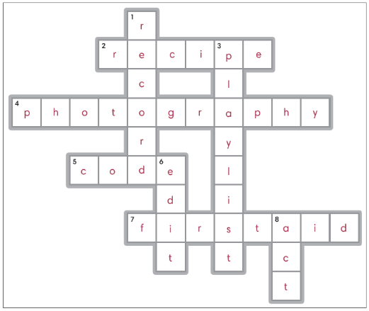

Across:
2. recipe
4. photography
5. code
7. first aid

Down:
1. record
3. playlist
6. edit
8. act

Speaking

A.
1. No, I’m not going.
2. Yes, he is. He plays the piano.
3. Yes, I do.
4. Yes, I will.

Grammar

A.

1. Won’t you create a playlist?

2. Isn’t Mary trying a new recipe tonight?

3. Don’t your brothers record a podcast?

4. Shouldn’t the students take a first aid course?

B

1. don’t you

2. won’t she

3. can’t you

4. aren’t we

5. won’t we

CLIL

B
1. c
2. a
3. b

C
1. F
2. T
3. F

Reading & Writing

A.
- join
- language
- instrument
- course
- video
- podcast
- code
- website
- photography

B.
- b

C.
- T
- T
- F

Unit 2: An Accident-filled Day

A.
- lose
- drop
- knock
- spill
- break
- find
- trip
- smash

B.
- P
- PP
- PP
- PP
- P
- PP
- P
- P

C.
1. c
2. a
3. d
4. b

D
- have
- knocked over
- tripped
- broke
- have
- found
- smashed
- dropped

Listening

A.
- b
- a
- a
- a
- b

B.

a

b

b

a

Writing

A.
- I lost my wallet.
- He has just knocked over a vase.
- She dropped her ice cream.
- They have just tripped.

B.
1. has just spilled
2. smashed / broke
3. has just broken
4. has just lost

Vocabulary

A.

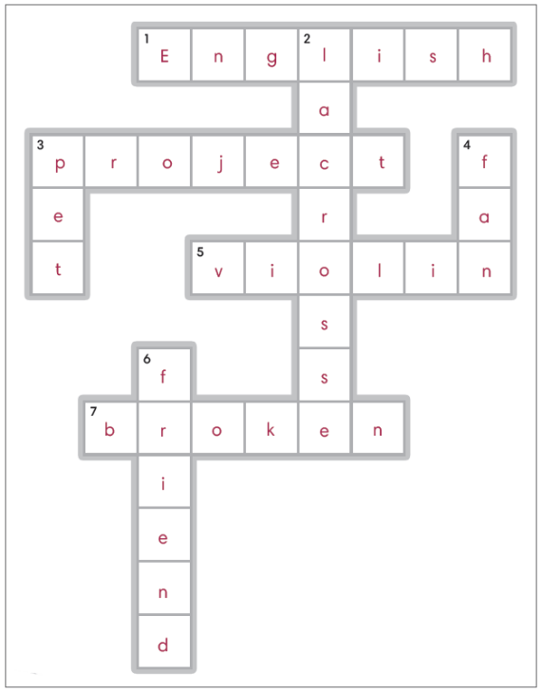

Across:

1. English

3. project

5. violin

7. broken

Down:

2. lacrosse

3. pet

4. fan

6. friend

Speaking

A.
- for
- since
- have
- How long

Grammar

A.
- have just spilled / spilled
- tripped
- dropped
- broke

B.
- I have played lacrosse since
- I have known my best friend for
- Simon has worked on the project for
- My sister has played the violin for

CLIL

B.
1. animal sanctuary
2. goats
3. schools

C.
1. T
2. T
3. F

Reading & Writing

A.
- fan
- since
- for
- tripped
- broke
- dropped
- break
- friend
- known

B.
- c

C.
- The writer, two months
- violin
- Fiona, cello

Unit 3: Great Ideas from the Past

A.
- Seat belt
- cement
- light bulb
- elevator
- telephone
- thermometer
- microscope
- compass

B.
- compass
- elevator
- microscope
- thermometer
- seat belt
- cement
- telephone
- light bulb

C.
1. True
2. False
3. True
4. False

D.
1. telephone
2. invented
3. invention
4. was
5. by
6. in

Listening

A.
- False
- False
- False
- True
- True
- False

B.
- c
- a
- b

Writing

    - Wright
    - invented
    - was
    - Adam Osborne

Vocabulary

- Eiffel Tower
- X-ray
- Taj Mahal
- Empire State
- Golden Gate Bridge
- oxygen
- Pluto
- gravity
Q: Who ate the family dinner?
A: It was eaten by Max the turtle.

Speaking

A.
1. It was discovered in 1930.
2. When was the Empire State Building built?
3. It was built in 1937.
4. It was discovered in 1772.

Grammar

A.

DNA was discovered in 1869 by Friedrich Miescher.

The windscreen wiper was invented in 1903 by Mary Anderson.

The magnifying glass was invented in 1268 by Roger Bacon.

The steam engine was invented in 1775 by James Watt.

Nuclear energy was discovered in the 1930s by Enrico Fermi.

B.
- discovered
- was, invented
- When was the magnifying glass invented?
- When was the steam engine invented?
- When was nuclear energy discovered?

CLIL

B.
1. c
2. a
3. b

C.
1. F
2. T
3. T

Reading & Writing

A.
- Eiffel Tower
- Taj Mahal
- built
- telephone
- compass
- light bulb
- invented
- oxygen
- discovered

B.
- b

C.
- F
- T
- T

Unit 4: You Should Have…

A.
- copy
- say
- ask
- be
- train
- gossip
- Tell
- cheat

B.
- cheated
- asked
- been
- copied
- told
- trained
- told
- gossiped

C.
1. d
2. c
3. b
4. a

D.
1. been
2. have
3. told
4. gossiped
5. should’ve
6. cheated
7. have
8. trained

Listening

A.
1. a
2. b
3. a
4. b
5. b

B.
- d
- a
- c
- b

Writing

A.

Robert should have told the truth about the chocolate.
- Rebecca should not have gossiped about her classmates.
- Gina should have been more respectful to her teacher.
- Hamza should have trained more this year.

B.

have copied

shouldn’t have cheated on the

should have asked for permission

should have said sorry to

Tim should have been respectful to Ben.

Vocabulary

A.

h,fail

f, grounded

d, grades

b, guilty

a, award

c, punished

e, detention

g, fight

B

award

grounded

punished

detention

failed

fight

grades

guilty

Speaking

A.
- been
- hadn’t
- wouldn’t

Grammar

A.
- should have told the truth
- She should not have cheated on the test.
- You should have said sorry.
- They should have trained more.

B.
- If I hadn’t copied someone’s homework, I wouldn’t have gotten detention.
- If I had asked for permission, I wouldn’t have gotten punished.
- If I had trained more, I would have won an award.
- If I hadn’t told the truth, I would have felt guilty.

CLIL

B.
1. b
2. c
3. a

C.
1. F
2. F
3. T

Reading & Writing

A.
- respectful
- gossip
- fight
- detention
- guilty
- said
- copied
- grades
- award

B.
- b

C.
1. the writer
2. study hard
3. Mrs. Tanaka

Unit 5: Being a Tourist

A.
- wander
- culture
- sights
- observe
- backpacking
- socialize
- explore
- observe

B.

sample

observe

wander

sights

backpacking

culture

socialize

places

C.
1. b
2. a
3. d
4. c

D.
1. explore
2. plans to wander
3. observe
4. locals
5. decided
6. expect
7. hoped
8. experience

Listening

A.
1. False
2. True
3. False
4. True
5. True
6. False

B.
1. b, socialize with the locals
2. a, take in the sights
3. d, sample the food
4. observe the wildlife

Writing

    - explore new places
    - take in the sights
    - Te Puia
    - hot springs
    - Maori

Vocabulary

- overcrowd
- poach
- ruin
- destroy
- waste
- ignore
- disrespect
- endanger
A: Everyone likes a good tourist.

Speaking

A.
- b
- a
- b
- a

Grammar

A.
- I want to explore the old town.
- I hope to experience the local culture at a carnival.
- Fred expected to learn about history at the museum.
- We decided to go to a famous cafe in the city.

B.
- Destroying nature is an issue in the mountains.
- Overcrowding is a problem at the beach.
- Wasting water is a concern at the hotel.
- Disrespecting local customs is an issue at the palace.

CLIL

B.
1. c
2. a
3. b

C.
  - F
  - T
  - F

Reading & Writing

A.
- destination
- explored
- observed
- endanger
- ignore
- overcrowding
- resources
- culture
- ruin

B.
- c

C.
- in British Columbia
- feed
- lived on

Unit 6: You Must Be…

A.
- overwhelmed
- disappointed
- painful
- impressed
- confusing
- exhausted
- offensive
- jealous

B.
- exhausted
- impressed
- jealous
- overwhelmed
- disappointed
- painful
- offensive
- confusing

C.
1. d, impressed
2. c, exhausted
3. b, disappointed
4. a, jealous

D.
1. offensive
2. confusing
3. jealous
4. overwhelmed
5. painful
6. impressed

Listening

A.
1. b
2. a
3. b
4. a
5. a

B.
1. overwhelmed
2. disappointed
3. impressed
4. jealous

Writing

A.
- My uncle has just cycled across the whole country. I’m impressed. He must be proud of himself.
- You must be happy with your exam results. I am. I really thought I’d failed math.
- My mom has a new job, a professor at the university. That’s great. Your mom must be very clever.
- Our school ice hockey team just won the national championships. They must be so delighted.
- It must be exciting to visit India. Would you like to go? Yes, I would, but the hot weather must be tiring.

Vocabulary

A.
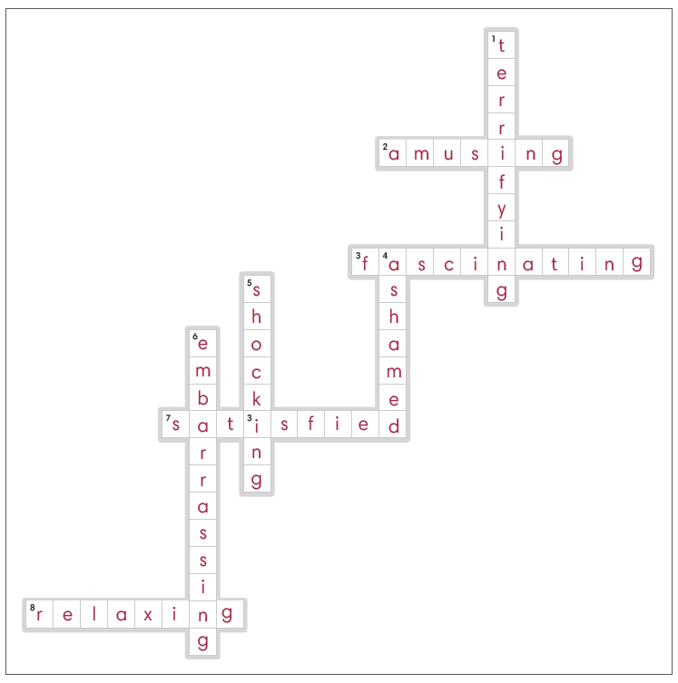
Across:
2. amusing
3. fascinating
7. satisfied
8. relaxing

Down:
1. terrifying
4. ashamed
5. shocking
6. embarrassing

Speaking

A.
- terrifying
- fascinating
- satisfied
- relaxing

Grammar

A.
- confused
- terrifying
- disappointing
- be painful
- overwhelming

B.

He must have been hungry.

I must have been exhausted.

She must have been embarrassed.

He must have been angry.

CLIL

B.
- B
- c
- a

C.

yak herder

crack

roof

Reading & Writing

A.
- overwhelming
- embarrassing
- terrified
- fascinating
- jealous
- confused
- relaxing
- impressed
- exhausted

B.
- c

C.
- himself
- plants
- tired

Unit 7: I Wish I Were…

A.
- older
- creative
- talented
- license
- yacht
- Older
- retired
- credit

B.
- yacht
- retired
- driver’s license
- credit card
- older
- creative
- wealthy
- talented

C.
1. c, had a driving license
2. d, were older
3. a, had a credit card
4. b, were creative

D.
- b
- a
- b
- a
- b

Listening

A.
- d, credit card
- a, yacht
- e, driver’s license
- c, older
- b, wealthy

B.
- T
- F
- T
- F
- T

Writing

A.
- had
- wish
- were
- were
- wish
- Do

B.
Answers will vary.

Vocabulary

A.
- online
- start
- sail
- donate
- album
- apply
- offer
- volunteer
Q: What does he wish?
A: He wishes he had a submarine.

Speaking

A.
- would
- had
- were
- had

Grammar

A.
- She wishes she had a new pair of shoes.
- My brother wishes he had a tennis racket.
- I wish I were an airline pilot.
- He wishes he could play the saxophone.

B.
- If I started a business, I would open a coffee shop.
- If I were wealthy, I would donate all my money to charity.
- If I had a swimming pool, I would swim every day.
- If I were talented, I would record an album.

CLIL

B.

catamaran

sport fisher

mega-yacht

C

T

F

T

F

Reading & Writing

A.
- creative
- driver’s license
- offer rides
- volunteer
- shop online
- credit card
- yachts
- sail around the world
- wealthy

B.
- a

C.
- F
- T
- F

Unit 8: The Future

A.
- planet
- underwater
- space tourism
- moon
- jetpack
- space elevator
- space
- rocket

B.
- space elevator
- planet
- Space tourism
- underwater
- rocket
- space
- moon
- jetpack

C.
1. d
2. c
3. b
4. a

D.
1. will
2. travel
3. use
4. travel

Listening

A.
- a
- b
- a
- b
- b

B.
- b
- b
- b
- c

Writing

C.
- travel to different planets
- will travel to space on rockets
- Where will we live?
- In our free time, we will have jetpack races.
- people come to visit

Vocabulary

A.
- c, virtual school
- f, AI friend
- h, travel through time
- b, tall tower
- a, hologram
- e, robot
- d, drone
- g, charge

B.
- have virtual schools
- have AI friends
- fly drones
- own robots
- use holograms
- live in tall towers
- travel through time
- charge our cars

Speaking

A.
- Yes, we will.
- holograms
- in outer space
- in the future

Grammar

A.
- live
- will we
- own
- have

B.
- own, we won’t own robots
- have, we will have virtual schools
- travel, No, we won’t travel through time.
- live in, Yes, we will live in very tall towers.

CLIL

B.
1. Honda.
2. university.
3. 2050.

C.
1. False
2. True
3. True

Reading & Writing

A.
- space
- planet
- ride a rocket
- jetpack
- tower
- owns robots
- drones
- AI friends
- holograms

B.
- c

C.
- water
- robots
- astronaut

Unit 9: Rules and Laws

A.
- lawn
- fast food
- laundry
- sibling
- curfew
- breakfast
- allowance
- tablet

B.
- curfew
- mow
- laundry
- allowance
- breakfast
- fast food
- sibling
- tablet

C.
1. d
2. a
3. b
4. c

D.
- lets, tablet
- let, fast food
- makes, curfew
- make, laundry
- has, breakfast
- let, allowance
- has, siblings
- makes, lawn

Listening

A.
- b
- a
- a
- b

B.
- prepare my own breakfast, make me
- let me get, mow the lawn
- let me, curfew
- lets me eat, will not let me get

Writing

A.
1. Her mom will not let her eat fast food.
2. His dad makes him look after his siblings.
3. My parents make me have a curfew.
4. Her parents will not let her get an allowance.
5. Why does her mom make her do her own laundry?

B.
Answers will vary.

Vocabulary

A.
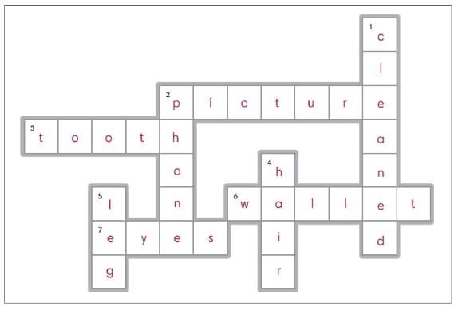
Across:
2. picture
3. tooth
6. wallet
7. eyes

Down:
1. cleaned
2. phone
4. hair
5. leg

Speaking

A.
- I had my wallet stolen.
- I got my hair cut.
- I had my tooth removed.
- I got my eyes tested.

Grammar

A.
- made, clean
- let, stay
- had, cook
- had, take

B
- I got my wallet stolen.
- I got my clothes dry cleaned.
- Jon had his computer fixed.
- My sister had her phone repaired.
- Dad got his car washed.

CLIL

B.
1. 19 kph
2. driver’s licenses
3. glass

C.
1. before
2. made
3. car companies

Reading & Writing

A.
- stolen
- allowance
- tablet
- mow the lawn
- eat fast food
- prepare
- laundry
- dry cleaned
- picture

B.
- a

C.
- b
- c
- a

Unit 10: Achieving My Goals

A.
- contest
- service center
- band
- crowd
- school
- experiments
- work out
- cabin

B
- will
- doing
- attending
- leading
- contacting
- participating
- working out
- to

C.
- c, leading his band
- a, participating in a contest
- d, contacting the service center
- b, renting a cabin

D
- e
- a
- b
- c
- d

Listening

A
        - c
        - d
        - b
        - a

B
- going
- performing
- attending
- leading
- playing
- working
- renting
- climbing
- coming

Writing

A.
- Tomorrow, I will be practicing German.
- On Tuesday, I will be studying for a test.
- On Wednesday, I will be competing in an art contest.
- The next day, I will be reading comics.
- On Friday, I will be watching my brother play soccer.
- On Saturday, I will be having a family barbecue.
- On Sunday, I will be taking a rest.

B
Answers will vary.

Vocabulary

A.
- g, world
- e, salary
- h, content
- f, graduation
- a, app
- b, disease
- c, studies
- d, elderly

B.
- create content
- assist the elderly
- create an app
- concentrate on studies
- tour the world
- earn a big salary
- cure a disease
- celebrate graduation

Speaking

A.

I think I will be celebrating graduation.

I imagine I will be working as a firefighter.

She thinks she will be traveling around Europe with her family.

I expect it will be leaving in a few minutes.

Grammar

A.
- He will be celebrating graduation.
- I will be curing a disease.
- My mom will be creating an app.
- My brother will be assisting the elderly.

B
- I will be earning a big salary
- She thinks she will be developing content.
- He thinks he will be concentrating on his studies.
- I guess I will be going swimming tonight.

CLIL

B.

school

shade

cheap

C
- c, Jouberton
- a, the University of Nottingham
- b, money
- f, a charity
- d, local businesses
- e, to South Africa

Reading and Writing

A.
- participating
- contest
- crowd
- tour
- salary
- content
- app
- working
- studies

B
- c

C.
- get a great experience
- entertain people
- working

