Unit 1 My First Day at School
Warm-Up
A (Answers may vary.)
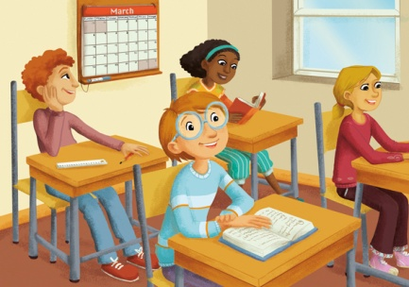
1
2
3
4
5
6
B
1. b
2. c
3. a

Listening Practice 1
A
1. Mary Jones
2. 12
3. Michael

B
1. b
2. d
3. a
4. c

C
1. what’s
2. name
3. good

Listening Practice 2
A
First, Sally, Wears, glasses

B
1. c
2. d
3. d

Listening Practice 3
A
1. 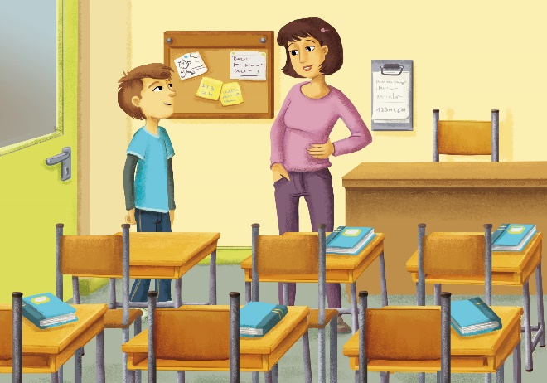
2. c

B
1. F
2. T

Speaking Practice
B
Students’ own answers
Example:
CHILD A: Hello! What’s your name?
CHILD B: My name is Frank.
CHILD A: How old are you?
CILD B: I’m 11 years old.
CHILD A: It’s nice to meet you, Frank.
C
Students’ own answers

On Your Own
(Answers will vary.)
Name? | How old? | Glasses? | Classroom?
Gina | 10 | Yes | 4A

Discover
- home
- parent
- lessons
- students

Wrap-Up
- a
- b
- b

Quiz
A
1. c
2. a
3. d
4. b

B
5. c
6. b

C
7. T
8. F

D
9. b
10. a
Unit 2 My Day
Warm-Up
A (Answers may vary.)
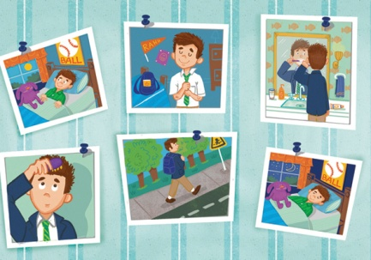
1
2
3
4
5
6
1
B
1. c
2. a
3. b

Listening Practice 1
A
1. in the morning
2. before dinner
3. fun

B
1. d
2. a
3. c
4. b

C
1. after school
2. go
3. soccer

Listening Practice 2
A
Bedtime, Puts, Brushes, teeth

B
1. c
2. d
3. b

Listening Practice 3
A
 | George | Kiki
Plays the guitar |  | √
Skateboards in the park | √
Sleeps in |  | √

B
1. F
2. T

Speaking Practice
B
Students’ own answers
Example:
CHILD A: What do you do in the morning?
CHILD B: I meet my friends. How about you?
CHILD A: I listen to music.
C
Students’ own answers

On Your Own
(Answers will vary.)
Name | In the morning? | After school? | Before bedtime?
Susie | eats breakfast | does homework | listens to music

Discover
- Exercise
- early
- breakfast
- habits

Wrap-Up
2, 4, 3, 1

Quiz
A
1. a
2. b
3. c
4. a

B
5. b
6. a

C
7. T
8. F

D
9. b
10. a

Unit 3 All of Us
Warm-Up
A (Answers may vary.)
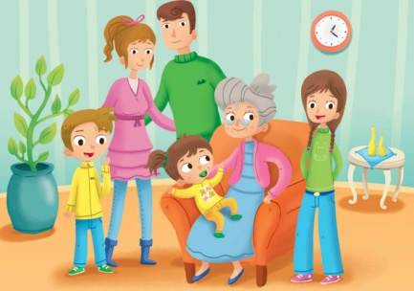
1
2
3
4
5
6
B
1. c
2. a
3. b

Listening Practice 1
A
1. sister
2. brother
3. 5

B
1. a
2. b
3. d
4. c

C
1. any brothers
2. Do
3. brother

Listening Practice 2
A
little, name, Lisa, grandparents

B
1. c
2. d
3. b

Listening Practice 3
A
Natalie’s Brothers and Sisters
Name | Age | Looks
Tommy | baby | cute
Kelly | 14 | long hair

B
1. T
2. F

Speaking Practice
B
Students’ own answers
Example:
CHILD A: Who is this?
CHILD B: He’s my cousin.
CHILD A: How old is he?
CHILD B: He’s 15 years old.
C
Students’ own answers

On Your Own
(Answers will vary.)
Name | Sisters? | Brothers? | Live with?
Mason | 1 | no | parents

Discover
- children
- grandparents
- help
- lonely

Wrap-Up
checked: grandparents, parents, aunt, sister, Irene, brother (baby)

Quiz
A
1. d
2. a
3. b
4. c

B
5. c
6. a

C
7. T
8. T

D
9. b
10. a

Unit 4 At School
Warm-Up
A (Answers may vary.)
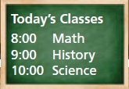
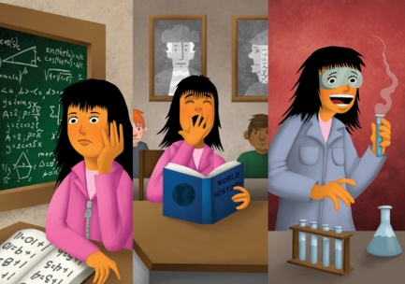
1
2
3
4
5
6
1
B
1. c
2. a
3. b

Listening Practice 1
A
1. teacher
2. subject
3. science

B
1. c
2. a
3. d
4. b

C
1. computer
2. interesting
3. favorite

Listening Practice 2
A
math, difficult, help, art

B
1. b
2. d
3. b

Listening Practice 3
A 2

B
1. F
2. T

Speaking Practice
B
Students’ own answers
Example:
CHILD A: Who is your favorite teacher?
CHILD B: My favorite teacher is Ms. Evans. She teaches computer class.
CHILD A: Oh, you do like computer class?
CHILD B: No, I don’t. It’s difficult.
C
Students’ own answers
Mr. Johnston – history
Ms. Evans – computer class
Mr. Rivers – art
Ms. Park – English
Mr. Fox – P.E.
Mrs. Smith – math
Mr. Hill – geography
Ms. Martin – science

On Your Own
(Answers will vary.)
Name | Favorite teacher? | Favorite subject? | Difficult subject?
Mark | Ms. Quinn | P.E. | computers

Discover
- life
- languages
- people
- world

Wrap-Up
- e
- d
- a
- b
- c

Quiz
A
1. c
2. a
3. a
4. c

B
5. b
6. c

C
7. T
8. F

D
9. b
10. b

Unit 5 On the Farm
Warm-Up
A (Answers may vary.)
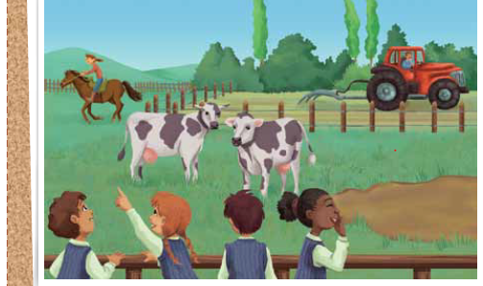
11
2
3
4
5
5
B
1. b
2. c
3. a

Listening Practice 1
A
1. are working
2. walking
3. running

B
1. d
2. c
3. b
4. a

C
1. visiting
2. farmer
3. is

Listening Practice 2
A
chickens, horses, water, milk

B
1. c
2. c
3. b

Listening Practice 3
A
Who | What They Are Doing
The boy and the girl | Visiting a farm
Joe | Feeding the horses
The horses | Eating/Eating food

B
1. T
2. F

Speaking Practice
B
Students’ own answers
Example:
CHILD A: Look at the cow.
CHILD B: What is it doing?
CHILD A: It’s eating grass.
C
Students’ own answers

On Your Own
(Answers will vary.)

Name | Like animals? | Favorite animal? | Ride a horse?
Justin | yes | horse | yes

Discover
- moved
- vegetables
- meat
- stay

Wrap-Up
3, 2, 1, 5, 4

Quiz
A
1. d
2. c
3. b
4. a

B
5. c
6. b

C
7. F
8. T

D
9. b
10. b

Unit 6 What Do You Want to Eat?
Warm-up
A (Answers may vary.)
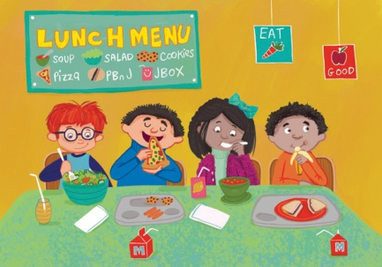
2
1
3
4
5
6
6
6
6
B
1. b
2. c
3. a

Listening Practice 1
A
1. make
2. salad
3. a banana

B
1. c
2. d
3. a
4. b

C
1. breakfast
2. bananas
3. have

Listening Practice 2
A
hungry, pizza, chicken, salad

B
1. a
2. c
3. d

Listening Practice 3
A
B
1. F
2. T

Speaking Practice
B
Students’ own answers
Example:
CHILD A: What do you want to eat for lunch?
CHILD B: I want to have a hamburger.
CHILD A: That sounds good. What do you want to drink?
CHILD B: I want some milk.
C
Students’ own answers

On Your Own
(Answers will vary.)
Name | Dinner? | Drink? | Dessert?
Becky | pizza | milk | fruit

Discover
- quick
- fry
- omelets
- taste

Wrap-Up
checked: a, b, d, f

Quiz
A
1. b
2. c
3. a
4. a

B
5. b
6. b

C
7. T
8. F

D
9. b
10. b
Unit 7 Let’s Go Shopping!
Warm-Up
A (Answers may vary.)
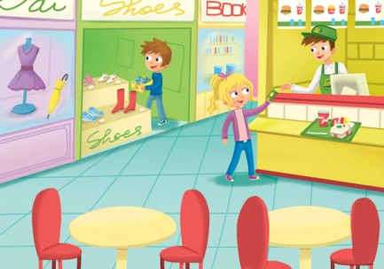
1
2
3
4
5
6
B
1. c
2. b
3. a

Listening Practice 1
A
1. glasses
2. bookstore
3. money

B
- a
- c
- b
- d

C
1. bookstore
2. between
3. animals

Listening Practice 2
A
Saturday, in front of, mall, 10

B
1. c
2. d
3. a

Listening Practice 3
A
1. Reading Time
2. Mike’s Books
3. Great Plates

B
1. F
2. T

Speaking Practice
B
Students’ own answers
Example:
CHILD A: I need to get a book.
CHILD B: OK, then let’s go to the bookstore.
CHILD A: Sure. Where is it?
CHILD B: It’s in front of the food court.
C
Students’ own answers

On Your Own
(Answers will vary.)
Name | Favorite store? | Buy there? | Near?
Max | Capital Books | a lot of books | computer store

Discover
- market
- bigger
- malls
- easier

Wrap-Up
- food court
- T-shirt store
- bakery
- bookstore

Quiz
A
1. c
2. a
3. d
4. b

B
5. c
6. b

C
7. T
8. F

D
9. b
10. a

Unit 8 Weekends Are Fun
Warm-Up
A (Answers may vary.)
1
2
3
4
5
6
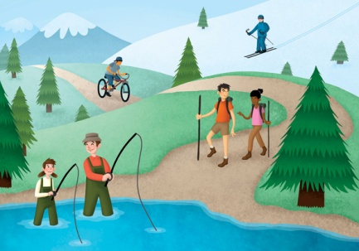
B
1. a
2. c
3. b

Listening Practice 1
A
1. weekend
2. did
3. went

B
1. c
2. d
3. a
4. b

C
1. last weekend
2. buy
3. a new bicycle

Listening Practice 2
A
(Went) Skiing, Maria, tomato, soup

B
1. b
2. b
3. d

Listening Practice 3
A
 | Bought hiking shoes | Likes hiking | Went fishing | Had a good weekend
Tina | X | √ | √ | √
Greg | √ | √ | X | √

B
1. F
2. T

Speaking Practice
B
Students’ own answers
Example:
CHILD A: Where did you go on the weekend?
CHILD B: I went to the lake.
CHILD A: What did you do there?
CHILD B: I went hiking. It was great.
C
Students’ own answers

On Your Own
(Answers will vary.)
Name | Have fun? | Did? | What else?
Julia | no | history homework | studied for math test

Discover
- nature
- forest
- camp
- enjoy

Wrap-Up
Fiona did NOT: a, d

Quiz
A
1. a
2. b
3. c
4. a

B
5. b
6. a

C
7. T
8. T

D
9. a
10. a

Unit 9 We Won!
Warm-Up
A (Answers may vary.)
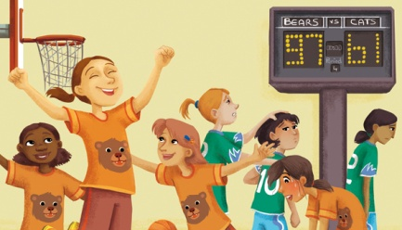
1
2
3
4
5
6
1
B
1. c
2. a
3. b

Listening Practice 1
A
1. lost
2. play
3. tired

B
1. c
2. d
3. a
4. b

C
1. won
2. goals
3. well

Listening Practice 2
A
Tennis, play, well, Soccer

B
1. c
2. a
3. c

Listening Practice 3
A
 | Travis got new skis. | Jenny is on a ski team. | Everyone on the team skis fast. | The team skis on Sundays.
Yes | √ |  | √
No |  | √ |  | √

B
1. F
2. T

Speaking Practice
B
Students’ own answers
Example:
CHILD A: How was your tennis match?
CHILD B: It was fun. I played well.
CHILD A: Oh, I see. Did you score any points.
CHILD B: No, I didn’t. I didn’t score any points. We lost!
C
Students’ own answers

On Your Own
(Answers will vary.)
Name | Sport? | How often? | Play well?
Blake | basketball | once a week, Fridays | yes

Discover
- win
- team
- lose
- best

Wrap-Up
Steve: a, c
Jerry: b, d

Quiz
A
1. d
2. c
3. a
4. b

B
5. a
6. c

C
7. F
8. F

D
9. b
10. b

Unit 10 My Party!
Warm-Up
A (Answers may vary.)
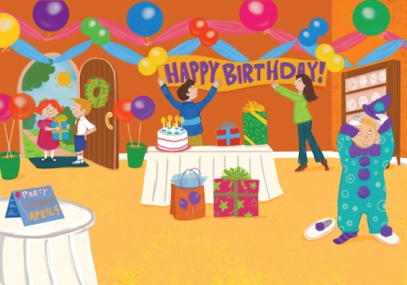
1
2
3
4
5
6
B
1. a
2. c
3. b

Listening Practice 1
A
1. birthday
2. an invitation
3. want

B
1. d
2. b
3. a
4. c

C
1. When
2. on Tuesday
3. costume

Listening Practice 2
A
Basketball, Tomorrow, house, 1

B
1. b
2. c
3. b

Listening Practice 3
A 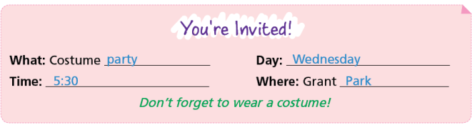B
1. T
2. F

Speaking Practice
B
Students’ own answers
Example:
CHILD A: I’m having a New Year’s Eve party on Tuesday. Can you come?
CHILD B: Sure! What are you doing at the party?
CHILD A: We’re exchanging presents and playing board games.
CHILD B: That sounds like fun!
C
Students’ own answers

On Your Own
(Answers will vary.)
Name | Party? | Wear? | Do?
Jessica | school party | cat costume | ate cake and listened to music

Discover
- invitations
- decorations
- cook
- cleaning

Wrap-Up
- Yes
- No
- Yes
- Yes

Quiz
A
1. a
2. b
3. b
4. c

B
5. c
6. a

C
7. F
8. T

D
9. a
10. b

Unit 11 How Is the Weather?
Warm-Up
A (Answers may vary.)
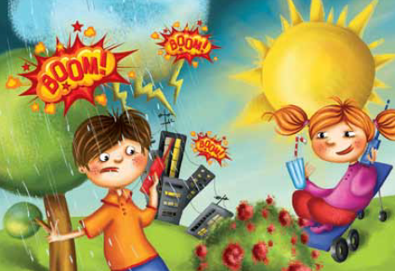
2
1
3
5
4
6
B
1. c
2. b
3. a

Listening Practice 1
A
1. sunny
2. watched
3. go running

B
1. a
2. c
3. d
4. b

C
1. sunny
2. rain
3. will be

Listening Practice 2
A
sunny, lightning, weather, report

B
1. b
2. b
3. c

Listening Practice 3
A
Weather Report
Friday | Saturday | Sunday
snow | snow | rain

B
1. T
2. F

Speaking Practice
B
Students’ own answers
Example:
CHILD A: What’s the weather like today?
CHILD B: It’s cold.
CHILD A: Will it snow in the afternoon?
CHILD B: No, I think it will clear up.
C
Students’ own answers

On Your Own
(Answers will vary.)
Name | Favorite weather? | Weather today? | Do if it rains?
Darren | thunder and lightning | sunny and hot | stay at home

Discover
- dangerous
- hit
- travels
- inside

Wrap-Up
- d
- b
- a
- c

Quiz
A
1. a
2. d
3. b
4. c

B
5. c
6. c

C
7. F
8. T

D
9. b
10. a

Unit 12 Vacation Time
Warm-Up
A (Answers may vary.)
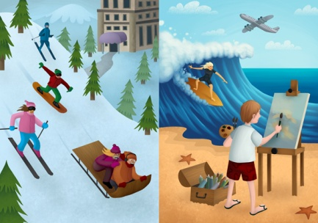
1
2
3
4
5
6
B
1. c
2. b
3. a

Listening Practice 1
A
1. winter
2. France
3. are going to have

B
1. d
2. a
3. c
4. b

C
1. weekend
2. friend’s
3. hiking

Listening Practice 2
A
go, Canada, sledding, skiing

B
1. d
2. b
3. d

Listening Practice 3
A
James
• Is going to painting camp
• (Is / Is not) going to become an excellent painter
• Will try to paint Sally
Sally
• Is going to surf every day
• Wants great weather this summer
• Invited James to watch her surfing

B
1. F
2. T

Speaking Practice
B
Students’ own answers
Example:
CHILD A: Are you going to do anything special this spring break?
CHILD B: Yes, I’m going to go to Japan.
CHILD A: What are you going to do there?
CHILD B: I’m going to go camping.
C
Students’ own answers

On Your Own
(Answers will vary.)
Name | Where? | Go with? | Do?
Dan | the Amazon | father and grandfather | go fishing

Discover
- outdoor
- crafts
- relaxing
- experience

Wrap-Up
Checked: b, c, e

Quiz
A
1. c
2. b
3. a
4. a

B
5. c
6. a

C
7. F
8. T

D
9. b
10. a

