Unit 1 Nice to Meet You.
A
1. confusing
2. enjoy
3. subject
4. move
B
1. introduction
2. job
3. works for
4. join
C
1. difficult
2. During
3. like
4. guess

Listening 1 Back to School
A
a. Mr. Thompson – 4
b. Jenny – 1, 5, 6
c. The new girl – 2
B
1. False
2. True
3. False
4. True
C
1. d
2. a
3. d

Listening 2 First Day at a New School
A
Alice
from Canada / new student / plays the piano
Alex
from England / new student
Jenny
plays the piano
Robert
12 years old / Alice’s brother
B
1. name
2. meet
3. dad
4. job
5. nice
6. brother
7. younger
8. England
9. apart
10. introduce
C
1. big
2. Alice’s
3. Alice
4. Alice, Jenny

Listening 3 The New Student
A
2, 4
B
1. F
2. F
3. T
4. F
C
1. c
2. b
3. c

Speaking Practice
B
Students’ own answers
Example:
CHILD A: Hi, where are you from?
CHILD B: I’m from New York. We moved here last month because my mom got a job here.
CHILD A: What do you like to do for fun?
CHILD B: I like to read books and play video games.

C
Students’ own answers

On Your Own
(Answers will vary.)
Name | How Old he/she is | Where he/she is from | Hobbies
Henry | 11 | Chicago | Plays the piano

UNIT TEST
A
1. a
2. a
B
3. d
4. d
C
5. b
6. c
7. d
8. b
D
9. c
10. d
11. b
12. c
E
13. a
14. c
15. d

Unit 2 This Is My Family.
A
1. c
2. a
3. d
4. b
B
1. come from
2. is married
3. looks cool
4. telling jokes
C
1. None
2. beard
3. near
4. used

Listening 1 Who Is She?
A
1. c
2. b
3. a
4. d
B
1. grandmother
2. grandfather
3. long
4. uncle
5. short
C
1. False
2. True
3. False
4. True
5. False

Listening 2 Do You Come from a Big Family?
A
1. (oldest) brother
2. sister
3. (other) brother
B
1. c
2. d
3. a
C
1. d
2. a
3. c
4. b
Listening 3 A Party!
A
1. birthday party
2. big family
3. telling jokes
4. dancing and singing
B
1. d
2. c
3. b
C
1. F The girl’s grandmother is active.
2. F Suzy is the girl’s (baby) cousin.
3. T
4. F The girl’s aunts and uncles are dancing and singing.

Speaking Practice
B
Students’ own answers
Example:
CHILD A: Do you come from a big family?
CHILD B: No, not really.
CHILD A: How many people are in your family?
CHILD B: There are three of us. There’s me, my mother, and my father.
C
Students’ own answers

On Your Own
(Answers will vary.)
Name | Family Size | Siblings | Description
Tara | 4 | Brother | Brother is older. He goes to college.

UNIT TEST
A
1. c
2. c
B
3. a
4. b
C
5. b
6. d
7. b
8. b
D
9. b
10. b
11. d
12. b
E.
13. a
14. d
15. d

Unit 3 What Do You Do at School?
A
1. PE
2. mine
3. help out
4. for a snack
B
1. c
2. a
3. a
4. a
C
1. worried about
2. semester
3. Sure
4. at least

Listening 1 What Classes Are You Taking?
A
art, PE, history, math, English, music
B
1. d
2. b
3. b
C
1. English
2. music
3. English
4. Alice

Listening 2 Do You Know Where My Pencil Case Is?
A
1, 3
B
4(a), 2(b), 3(c), 1(d), 5(e)
C
1. F There is an apple in the boy’s bag.
2. T
3. T
4. F The boy saw paint and brushes outside

Listening 3 Mondays
A
1. first class, easy
2. second class, fun
3. last class, hard
B
1. False
2. False
3. True
4. True
C
1. c
2. c
3. a

Speaking Practice
B
Students’ own answers
Example:
CHILD A: What classes do you have on Mondays?
CHILD B: I have science and art.
CHILD A: I have those classes, too. Which one is your favorite?
CHILD B: My favorite class is science because it is exciting.
C
Students’ own answers

On Your Own
(Answers will vary.)
Name | Classes | Favorite Class | Why
Dean | History, English, Math, PE | PE | Playing sports is fun

UNIT TEST
A
1. b
2. a
B
3. d
4. c
C
5. a
6. c
7. a
8. b
D
9. a
10. d
11. b
12. b
E
13. b
14. a
15. c

Unit 4 A Chance of Rain
A
1. carry
2. degree
3. get wet
4. forecast
B
1. cloudy
2. temperature
3. worse
4. chance
C
1. soon
2. Luckily
3. freezing
4. unusual

Listening 1 Don’t Forget Your Umbrella!
A
2, 3, 4
B
1. d
2. b
3. a

C
1. F She said it’s going to be cold and rainy.
2. F Jamie hates carrying an umbrella.
3. T
4. F There’s a 50% chance of rain.

Listening 2 It’s So Hot!
A
2, 4
B
1. b
2. a
3. c
4. d
C
1. a
2. a
3. b
4. d

Listening 3 Weather Changes
A
3,5

B
Weather Differences
 | 1. Last spring | 2. This spring | 3. This week | 4. Two days ago
Weather | - clear blue skies  - sunny and warm | cloudy | cold and rainy | freezing (temperatures)
Temperature (°C) | 28 degrees | — | — | below 0

C
1. False
2. False
3. True
4. False

Speaking Practice
B
Students’ own answers
Example:
CHILD A: It’s so cold outside today.
CHILD B: I know! It’s 5 degrees today!
CHILD A: It will be even colder next week. The weather forecast said it will be 0 degrees!
CHILD B: Wow! Let’s stay inside tomorrow!
C
Students’ own answers

On Your Own
(Answers will vary.)
Name | Today | Yesterday | Tomorrow
Sara | Stormy | Cloudy | Sunny

UNIT TEST
A
1. c
2. b
B
3. b
4. a
C
5. b
6. c
7. d
8. c
D
9. a
10. c
11. a
12. b
E
13. a
14. d
15. b

Unit 5 Where Is It?
A
1. d
2. b
3. a
4. c
B
1. behind
2. parrot
3. show
4. wall
C
1. of
2. beside
3. necklace
4. across

Listening 1 Have You Seen It?
A
2, 4, 7
B
1. dictionary OR pencil case
2. earring
3. CD OR (a pair of) socks
4. necklace
C
1. b
2. a
3. a

Listening 2 In My Brother’s Room
A
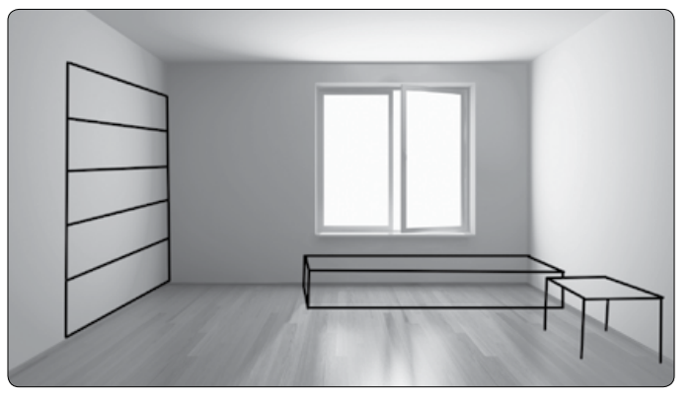
B
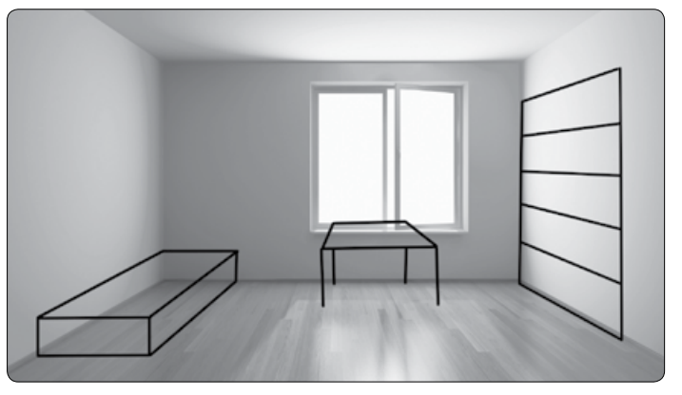
C
1. F The boy wants to change his room around.
2. F The boy doesn’t know how he wants to change the room.
3. T
4. T

Listening 3 My Favorite Poster
A
tiger, cheetah, monkey, parrot, snake, spider
B
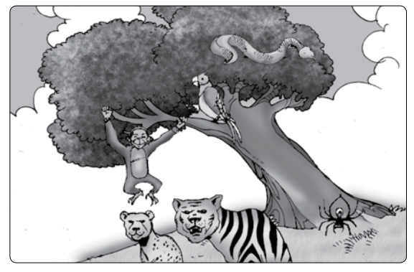
C
1. b
2. d
3. c
4. c

Speaking Practice
B
Students’ own answers
Example:
CHILD A: Did you lose something?
CHILD B: Yeah, do you know where my notebook is?
CHILD A: No, I don’t. Did you look in your backpack?
CHILD B: No, let me look. Oh no! It’s not there.
C
Students’ own answers

On Your Own
(Answers will vary.)
Name | Bed | Closet | Desk
Jenny | In the corner | Next to the door | Between the bed and the closet

UNIT TEST
A
1. b
2. c
B
3. a
4. b
C
5. d
6. d
7. b
8. c
D
9. c
10. d
11. b
12. b
E
13. a
14. b
15. c
Unit 6 How Do I Look?
A
1. striped
2. polka dot
3. on sale
4. try on
B
1. b
2. a
3. c
4. a
C
1. usually
2. Either
3. pants
4. dress

Listening 1 Nice Clothes!
A
pants, T-shirt

B
 | 1. Color | 2. Clothing
Jill | - orange  - purple | - dress  - shirt
Robert | - black  -brown | - shirt  - tie

C
1. False
2. True
3. False
4. True

Listening 2 Does It Look Good on Me?
A
1. a, b, c
2. d
3. f
4. e
B
1. polka dots
2. different color
3. try it on
4. think
5. buy
C
1. c
2. d
3. b
4. a

Listening 3 It Really Suits Her.
A
a, b, d, h
B
1. d
2. a, b
3. g
C
1. a
2. d
3. c

Speaking Practice
B
Students’ own answers
Example:
CHILD A: I really like that bright orange shirt. The colors look really cool.
CHILD B: I like the yellow checkered shirt better.
CHILD A: Oh, I didn’t see that one. That one is cool, too!
CHILD B: I want to buy it!
C
Students’ own answers
On Your Own
(Answers will vary.)
Name | Today | Yesterday | In the Future
John | Striped red shirt and black pants | Green long-sleeved shirt and blue jeans | Black sweatshirt

UNIT TEST
A
1. d
2. a
B
3. d
4. a
C
5. b
6. a
7. b
8. b
D
9. a
10. b
11. a
12. d
E
13. c
14. b
15. d

Unit 7 Be on Time!
A
1. chemistry
2. stop
3. sold out
4. aquarium
B
1. except
2. While
3. practice
4. literature
C
1. b
2. a
3. a
4. b

Listening 1 The School Trip
A
1. A
2. A
3. A
4. B
5. B
6. A
B
6:55 | 7:15 | 7:30 | 8:00 | 9:00 | 10:00 | Lunch time
d | a | e |  | c |  | b

C
1. a
2. b
3. a
4. b

Listening 2 Have a Good Trip!
A
1. China
2. Chinese
3. schoolwork
4. vacation
B
1. b
2. d
3. b
C
1. F It will be summer vacation soon.
2. F The boy will be in China for one month.
3. T
4. F The speakers will see each other next semester.

Listening 3 The Exam Schedule
A
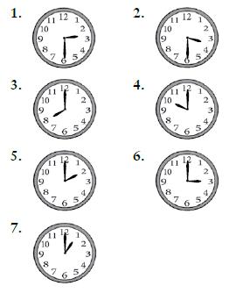
B
Subject | Day and Time of Exam
1. Literature | Friday 8:00
2. History | Friday 10:00
3. English | Monday 2:00
4. Chemistry | Tuesday 1:00
5. Math | Tuesday 3:00

C
1. False
2. True
3. False
4. True

Speaking Practice
B
Students’ own answers
Example:
CHILD A: When does the movie start?
CHILD B: It starts at 5:45 p.m. I want to get there at 5:30.
CHILD A: So, we should meet at 4:30 to get there on time.
CHILD B: Let’s meet at the park at 4:30. See you then!
C
Students’ own answers

On Your Own
(Answers will vary.)
Name | Wake-up Time | English Class | Dinner Time
Harry | 6:30AM | 10:15AM | 6:00PM

UNIT TEST
A
1. b
2. b
B
3. a
4. a
C
5. c
6. b
7. c
8. b
D
9. b
10. c
11. c
12. d
E
13. d
14. a
15. d

Unit 8 What Do You Like?
A
1. b
2. c
3. a
4. d
B
1. go out to eat
2. bite
3. dislike
4. lovely
C
1. kind of
2. take care of
3. spicy
4. miss

Listening 1 What Lovely Animals!
A
1. b
2. a, b
3. a
4. b
5. b

B
1. slow
2. scary, dangerous
3. cute
4. dangerous, dirty
5. beautiful
C
1. True
2. True
3. False
4. True

Listening 2 Vegetables!
A
burger, French fries, chicken, vegetables, fruit, strawberries, ice cream
B
1. chicken
2. vegetables
3. healthier
4. strawberries
5. ice cream
6. vegetables
C
1. b
2. a
3. c

Listening 3 I Like It Here.
A
1. b
2. b
3. a, b
4. a
B
1. b
2. b
3. c
C
1. F The man prefers big cities to small towns.
2. T
3. T
4. T

Speaking Practice
B
Students’ own answers
Example:
CHILD A: What is for dinner tonight? Is it fried chicken? I love fried chicken!
CHILD B: How about roasted chicken and carrots?
CHILD A: Carrots are OK. But do I have to have the roasted chicken? It’s not as good as fried chicken.
CHILD B: It’s healthier for you. Let’s have roasted chicken and carrots.
C
Students’ own answers

On Your Own
(Answers will vary.)
Name | Color | Food | Animal
Jill | Blue | Pizza | Bunny

UNIT TEST
A
1. c
2. a
B
3. b
4. a
C
5. a
6. c
7. d
8. d
D
9. b
10. b
11. a
12. b
E
13. c
14. b
15. d
Unit 9 It’s Math Time.
A
1. pond
2. prize
3. cost
4. piece
B
1. a
2. b
3. b
4. d
C
1. enough
2. each
3. subtract
4. add

Listening 1 How Many Dolls?
A
1. 50, 15
2. 3, 45
3. 5
B
1. help
2. 50
3. 15
4. 35
5. divided
6. 3
C
1. b
2. d
3. a

Listening 2 Surprise!
A
cake, drinks, snacks, plates, forks, birthday card, balloons
B
1. c
2. c
3. b
C
1. True
2. True
3. True
4. False

Listening 3 How Much?
A
notebooks, crayons, pens
B
1. e
3. c
5. d
C
1. a
2. c
3. c

Speaking Practice
B
Students’ own answers
Example:
CHILD A: We need to get ready for Mary’s birthday party! What do we need to buy?
CHILD B: Well, we need to buy food, drinks, and cups.
CHILD A: How much money do we need?
CHILD B: Let me think. The food will be $25, and the drinks and cups will be $10. So, we should only need about $35!
C
Students’ own answers

On Your Own
(Answers will vary.)
Name | Pencils | Erasers | Books
Nathan | Three pencils | One eraser | Four books

UNIT TEST
A
1. a
2. b
B
3. d
4. d
C
5. c
6. d
7. a
8. d
D
9. b
10. b
11. b
12. d
E
13. c
14. c
15. d

Unit 10 It Looks the Best!
A
1. b
2. c
3. a
4. d
B
1. almost
2. instead
3. only
4. cheaper
C
1. c
2. a
3. d
4. c

Listening 1 Buying a Gift
A
shirt, skirt, necklace
B
1. a
2. not used
3. b
4. c
5. e
C
1. F The pink skirt is more expensive than the red and blue shirt.
2. F The skirt is the most expensive item.
3. T
4. F Purple is Dean’s sister’s favorite color.

Listening 2 Is It New?
A
1. new OR newer OR big OR bigger
2. heavy OR heavier
3. fast OR faster
B
1. looks - much better
- newer
- bigger
2. feels - heavier
3. goes - faster
4. cost - a little more than 30 dollars
C
1. b
2. c
3. c

Listening 3 What Should I Get?
A
1. good
2. good
3. good
4. bad
B
1. Dad likes using his computer.
2. Books are better for an older person.
3. A pen is more useful.
4. Dad didn’t wear the shirt from last year. Clothes are the worst gift for a parent.
C
1. b
2. c
3. a

Speaking Practice
B
Students’ own answers
Example:
CHILD A: Wow, is that a new hat?
CHILD B: Yeah, I just got it yesterday! I’m excited to wear it.
CHILD A: That looks really cool. I really like the size!
CHILD B: Thanks. It is really comfortable, too!
C
Students’ own answers

On Your Own
(Answers will vary.)
Name | Backpack/Bag | Shoes | Pencils
Ron | Blue with a gray stripe. It has seven pockets. | Red with white shoe laces. | Black with a pink eraser on the end.

UNIT TEST
A
1. a
2. b
B
3. c
4. a
C
5. c
6. c
7. b
8. c
D
9. a
10. c
11. a
12. c
E
13. a
14. d
15. d
Unit 11 How Do I Get to the Library?
A
1. back
2. another
3. go straight
4. turn left
B
1. c
2. d
3. e
4. b
5. a
C
1. d
2. a
3. b
4. a

Listening 1 How Do I Get There?
A
4, 3, 1, 2
B
a
C
1. False
2. True
3. True
4. False

Listening 2 Do You Know Where?
A
1. a
2. d
3. f
4. c
B
1. a
2. a
3. a
C
1. not far from
2. the teacher’s office
3. on the third floor

Listening 3 A Question
A
zoo, bank, flower shop, department store, park

B
at the corner, turn left, turn right, on your left, on your right, down the street, next to, in front of, in the middle of
C
1. d
2. b
3. a

Speaking Practice
B
Students’ own answers
Example:
CHILD A: How do I get to the main office?
CHILD B: You have to turn left, then go through the doors.
CHILD A: Thank you! I need to ask for help.
CHILD B: Let’s go together!
C
Students’ own answers

On Your Own
(Answers will vary.)
Name | Library | English Class | The Gym
Tina | Turn left, then go straight | Turn right, then turn the corner | Go through the doors, then go straight

UNIT TEST
A
1. d
2. a
B
3. b
4. a
C
5. a
6. d
7. c
8. b
D
9. b
10. b
11. d
12. d
E
13. d
14. b
15. a
Unit 12 What Are You Going to Do?
A
1. a
2. d
3. b
4. c
B
1. coming up
2. relax
3. barbecue
4. invited
C
1. probably
2. day off
3. spend
4. rest of

Listening 1 The Holiday
A
winter break, New Year’s Eve party, visiting relatives, relaxing
B
1. winter break
2. on Dec 31st
3. this time of year
4. today
C
1. a
2. c
3. c

Listening 2 The Vacation
A
1.
2. ✔
3.
4. ✔
5.
6.
B
1. tomorrow
2. summer
3. nothing
4. vacation
5. ten
6. Mark
C
1. T
2. F There is nothing to do at Grandpa’s house.
3. F They are going to stay at Grandpa’s for ten days.
4. T
Listening 3 Coming Up
A
April, May, June, July
B
1. (not used)
2. April 1st to 7th
3. May 10th
4. June 15th
5. July 6th
6. (not used)
C
1. d
2. b
3. d

Speaking Practice
B
Students’ own answers
Example:
CHILD A: What are you doing for your vacation?
CHILD B: I’m going swimming with my sister. And you?
CHILD A: That sounds fun! I’m going to go hiking with my father.
CHILD B: That sounds fun, too! I hope you have a good time.
C
Students’ own answers
On Your Own
(Answers will vary.)
Name | Spring | Summer | Winter
Alice | Go hiking | Go swimming | Go snowboarding

UNIT TEST
A
1. b
2. b
B
3. a
4. d
C
5. b
6. d
7. b
8. d
D
9. a
10. b
11. c
12. a
E
13. c
14. c
15. c

