Reading Starter 2 / New Edition
Book 2 Unit 1-5
A. Fill in the blanks with the correct word.
1. A bird was very ____________. It wanted to drink the water.
a. sad | b. happy | c. lonely | d. thirsty
2. I have not been camping. Going to camp is an _____________.
a. signing up | b. schedule | c. enjoying | d. adventure
3. I go fishing in the _________.
a. forest | b. space | c. river | d. desert
4. I am drawing a vase. Oh, no! I made a ____________.
a. mistake | b. boring | c. adding | d. screen
5. I feel __________ before a test.
a. rabbit | b. nervous | c. hairdresser | d. come back

B. Match the related words.

1. bat |  | a. water
2. icon |  | b. computer
3. adventure |  | c. new place
4. thirsty |  | d. home run
5. water |  | e. river
C. Read and put the sentences in right order.

A dog had a piece of meat in his mouth. He was about to eat it. Then, he walked by a river. He looked into the water. He thought he saw another dog. It had a bigger piece of meat. He wanted to have that, too. He opened his mouth to take the other piece of meat. His piece of meat fell out of his mouth and dropped into the water. Oh, no! His meat was gone and the other dog’s meat was gone, too. The other dog was really just himself!

1. His meat dropped into the water.
2. He opened his mouth to take the other piece of meat.
3. A dog had a piece of meat in his mouth.
4. He walked by a river and looked into the water.
5. He saw a bigger piece of meat and wanted to have it.

_______ - _______ -_______ -_______-_______

Reading Starter 2 / New Edition
Book 2 Unit 6-10
A. Fill in the blank with the correct word.
1. We went to the __________ to do some shopping
a. mall | b. world | c. province | d. country
2. I don’t have time to clean my room now. I’ll do it _____________.
a. later | b. first | c. until | d. by
3. I want to be a teacher when I am an ___________
a. kid | b. adult | c. teenager | d. baby
4. The kangaroo keeps its baby in its _____________.
a. sack | b. car | c. bag | d. pouch
5. The __________ of this pizza is too high.
a. portion | b. height | c. price | d. size

B. Match the related words.
1. cheap  2. ice cream  3. price  4. female  5. hand | a. expensive  b. woman  c. cone  d. thumb  e. money

C. Read and answer the questions.
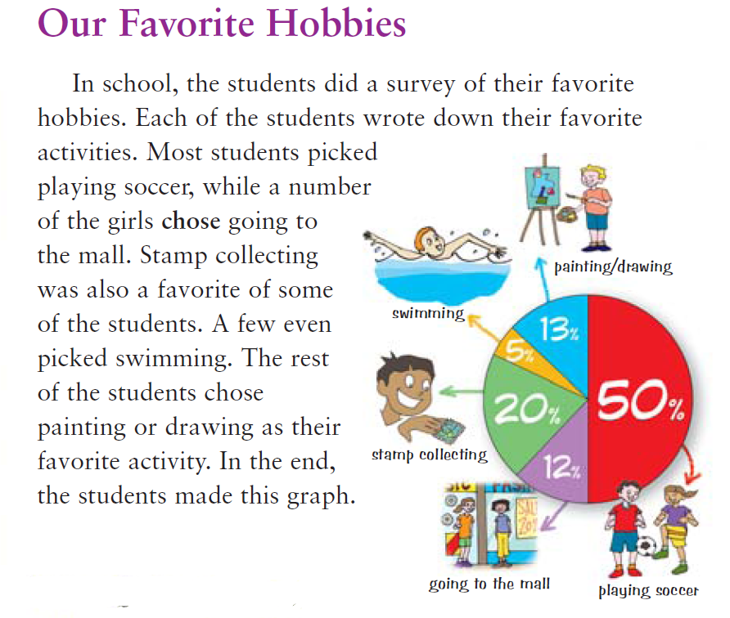

1. Five percent of the students likes to swim | True / False
2. Stamp collecting is an activity 5% of the students like. | True / False
3. Swimming is an activity 12% of the students like. | True / False
4. The largest group of students liked playing soccer. | True / False
5. The teacher made this graph. | True / False

Reading Starter 2 / New Edition
Book 2 Unit 11-15
A. Fill in the blanks with the correct word.
1. She is a(n) _____________ actor. She has been in many popular movies and dramas.
a. boring | b. successful | c. unpopular | d. nervous
2. I bought the present for my daughter. I have to ____________ it.
a. eat | b. sell | c. wrap | d. buy
3. I got a runny nose. I will take some ___________ to feel better.
a. medicine | b. drink | c. learning | d. ice cream
4. Don’t let the ____________ bite my baby.
a. fly | b. mosquito | c. butterfly | d. fish
5. Twilight is a five-book _____________
a. famous | b. popular | c. magic | d. series

B. Match the related words.

1. minute |  | a. cabin
2. celebrate |  | b. seconds
3. sick |  | c. character
4. camping |  | d. birthday
5. comic book |  | e. medicine

C. Circle True or False.
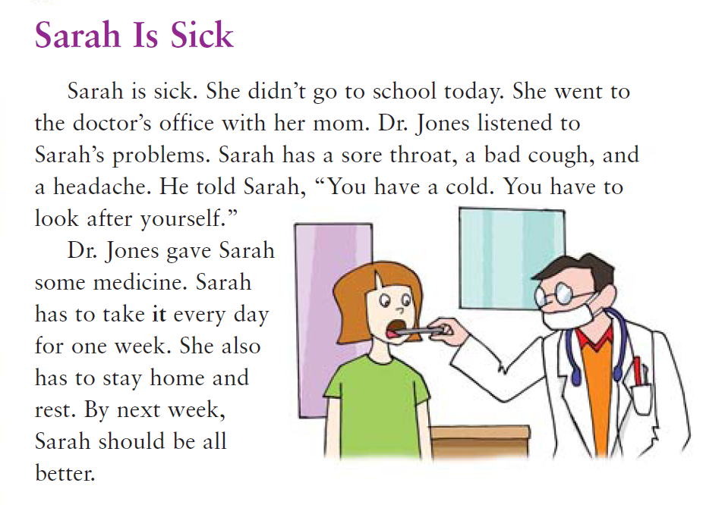

1. Sarah went to school and then to the doctor’s office. | True / False
2. Dr. Jones didn’t give Sarah any medicine. | True / False
3. Sarah has a sore throat. | True / False
4. Sarah has to stay home and rest for one week. | True / False
5. Sarah should get worse. | True / False

Reading Starter 2 / New Edition
Book 2 Unit 16-20
A. Fill in the blanks with the correct word.
interview | aquarium | remember | circle | notice
1. It is important to make a ____________ of rocks around the fire.
2. ____________, put out the fire before you leave!
3. Roberto has a cat, a hamster, and an ____________ full of fish.
4. Charlie ____________(e)s a big “Happy Birthday” banner.
5. This is Rick White. Thank you for letting Channel 9 News ____________ you.

B. Match the related words.

1. fire |  | a. home
2. living room |  | b. firefighter
3. dirt |  | c. picture
4. camera |  | d. clean
5. reptile |  | e. crocodile

C. Put them in right order.
Making a Campfire
1.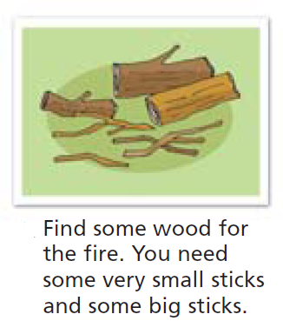 | 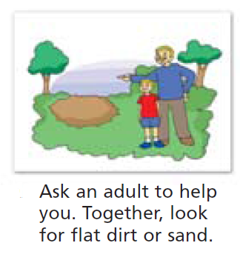2. | 3.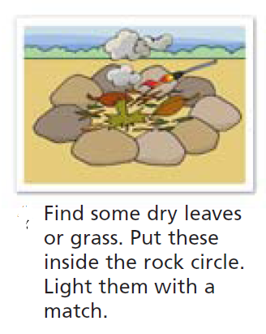
4.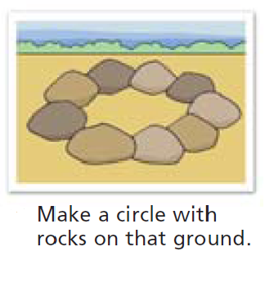 | 5.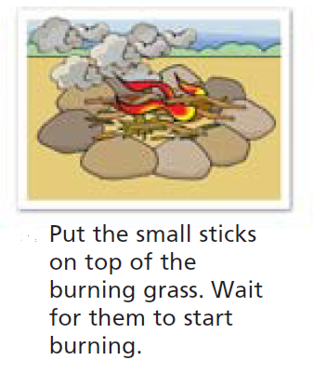 | 6.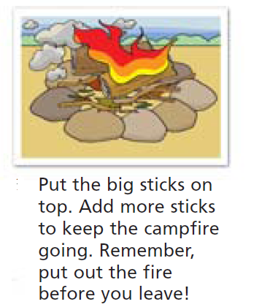

_________-_________-_________-_________-_________-_________

Reading Starter 2 / New Edition

Book 2 Unit 1-5
A.
1. d
2. d
3. c
4. a
5. b

B.
1- d
2- b
3- c
4- a
5- e

C.
1- d
2- b
3- c
4- a
5- e

Book 2 Unit 6-10
A.
1. a
2. a
3. b
4. d
5. c

B.
1. a
2. c
3. e
4. b
5. d

C.
1- T
2- F
3- F
4- T
5- F

Book 2 Unit 11-15
A.
1. b
2. c
3. a
4. b
5. d

B.
1. a
2. d
3. e
4. a
5. c

C.
1. F
2. F
3. T
4. T
5. F

Book2 Unit 16-20
A.
1. circle
2. Remember
3. aquarium
4. notice
5. interview

B.
1- b
2- a
3- d
4- c
5- e

C.
2-4-1-3-5-6

