School Subject Readings 3 Midterm Test
Units 1-10
A. Fill in the blanks with the correct word.
grant | pleased | sack | begs | church
cereal | kickball | study | point | shore
1. My friends and I play ______________ during recess.
2. My dog ______________ for food when we eat dinner.
3. I usually eat cold ______________ for breakfast.
4. It is not nice to ______________ at people.
5. I don’t swim in the ocean. I just stay on the ______________.
6. I have a test on Monday, so I have to ______________ all weekend.
7. My mother was ______________ that I got an A on the test.
8. The genie said he would ______________ me three wishes.
9. Please put these apples in a ______________.
10. I go to ______________ to pray.

B. Match the related words.
1. traffic | a. water
2. broom | b. elephant
3. meal | c. piano
4. practice | d. friend
5. pal | e. play
6. grant | f. cars
7. African | g. dinner
8. stage | h. clean
9. sink | i. game
10. kickball | j. wish
C. Read and circle True or False.
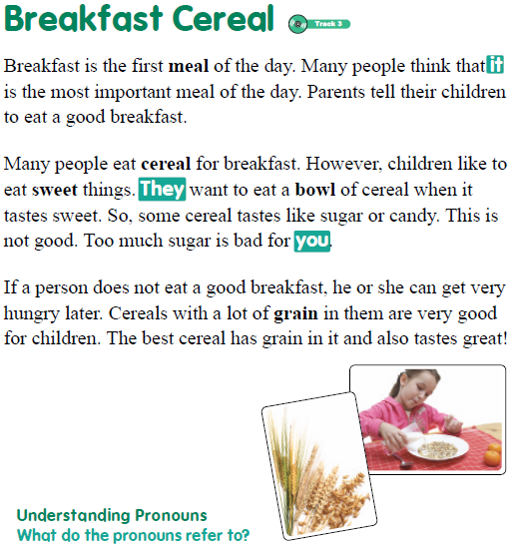
1. People eat breakfast before lunch. | True / False
2. Cereal is a popular breakfast. | True / False
3. Children should eat lots of sugary cereal. | True / False
4. Eating a lot of sugar is harmful to your health. | True / False
5. Grains are good for your health. | True / False

School Subject Readings 3 Midterm Test
Units 1-10

A.
1. kickball
2. begs
3. cereal
4. point
5. shore
6. study
7. pleased
8. grant
9. sack
10. church

B.
1. f
2. h
3. g
4. c
5. d
6. j
7. b
8. e
9. a
10. i

C.
1. True
2. True
3. False
4. True
5. True

